**LEARNER’S ACADEMY – A BACKEND ADMIN PORTAL**

This document contains the following

* Project and developer details
* Sprint planning and tasks achieved
* Core concepts used in the project
* Flowchart of the application
* Links to the GitHub repository
* Demonstration of product capabilities, appearance, and user interactions
* Unique Selling Points of the application
* Conclusion

# Project and Developer details:

**Project objective:**

As a Full Stack Developer, designed and develop a backend administrative portal for the Learner’s Academy. Use the GitHub repository to manage the project artifacts.

**Background of the problem statement:**

Learner’s Academy is a school that has an online management system. The system keeps track of its classes, subjects, students, and teachers. It has a back-office application with a single administrator login.

**The administrator can:**

* Set up a master list of all the subjects for all the classes
* Set up a master list of all the teachers
* Set up a master list of all the classes
* Assign classes for subjects from the master list
* Assign teachers to a class for a subject (A teacher can be assigned to different classes for different subjects)
* Get a master list of students (Each student must be assigned to a single class)

There will be an option to view a Class Report which will show all the information about the class, such as the list of students, subjects, and teachers  
       
The goal of the company is to deliver a high-end quality product as early as possible.

**The flow and features of the application:**

* Plan more than two sprints to complete the application
* Document the flow of the application and prepare a flow chart
* List the core concepts and algorithms being used to complete this application
* Implement the appropriate concepts such as exceptions, collections, and sorting techniques for source code optimization and increased performance

**You must use the following:**

* Eclipse/IntelliJ: An IDE to code for the application
* Java: A programming language to develop web pages, databases, and others
* SQL: To create tables for admin, classes, students, and other specifics
* Git: To connect and push files from the local system to GitHub
* GitHub: To store the application code and track its versions
* Scrum: An efficient agile framework to deliver the product incrementally
* Search and Sort techniques: Data structures used for the project
* Specification document: Any open-source document or Google Docs

**The following requirements should be met:**

* The source code should be pushed to your GitHub repository. You need to document the steps and write the algorithms in them.
* The submission of your GitHub repository link is mandatory. In order to track your task, you need to share the link to the repository. You can add a section to your document.
* Document the step-by-step process starting from sprint planning to the product release.
* Application should not close, exit, or throw an exception if the user specifies an invalid input.
* You need to submit the final specification document which includes:
  + Project and developer details
  + Sprints planned and the tasks achieved in them
  + Flowchart of the application
  + Core concepts used in the project
  + Links to the GitHub repository to verify the project completion

**Developer Details:**

Abilash Ravi

[abilashvicky235@gmail.com](mailto:abilashvicky235@gmail.com)

# Spring planning and Task completion:

This project is intended to be delivered in three sprints.

**Sprint 1:** Analysed the application’s features and prepared a flow chart and Git Repository. Implement the database schema for admin, classes, students, subjects, and teachers.

**Sprint 2:** Create basic CRUD operations for subjects, teachers, students, and classes. Implement the Class Report feature to display information about students, subjects, and teachers for a specific class.

**Sprint 3:** Tested the application numerous times to ensure a high-end quality product and pushed it to GitHub. Prepared this document highlighting the application’s capabilities, appease appearance and user interactions.

# Core concepts used in the project:

* CRUD Operations
* Exception Handling
* Authentication and Authorization
* Session Management
* Frontend technologies like HTML, CSS
* Java Server Pages (JSP)

# Links to the GitHub repository:

https://github.com/AbilashVicky/Learners_Academy.git

# Project Hierarchy

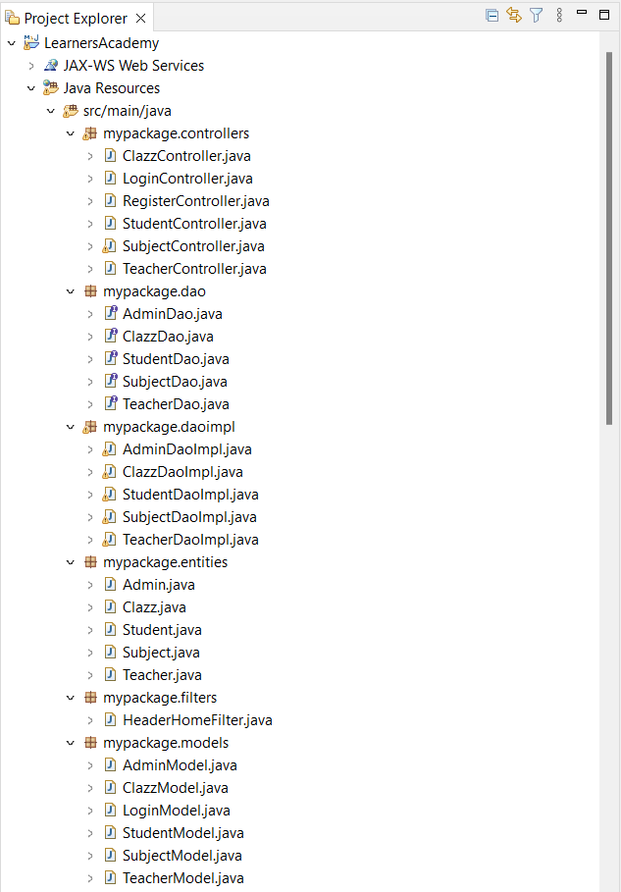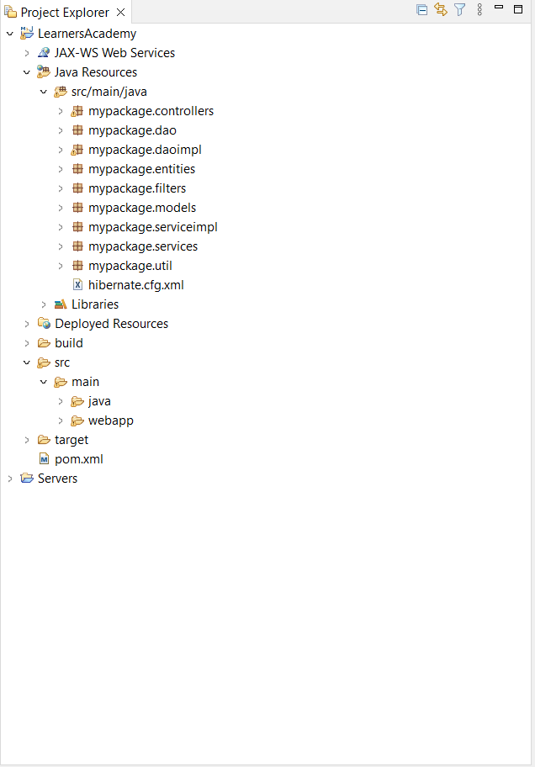

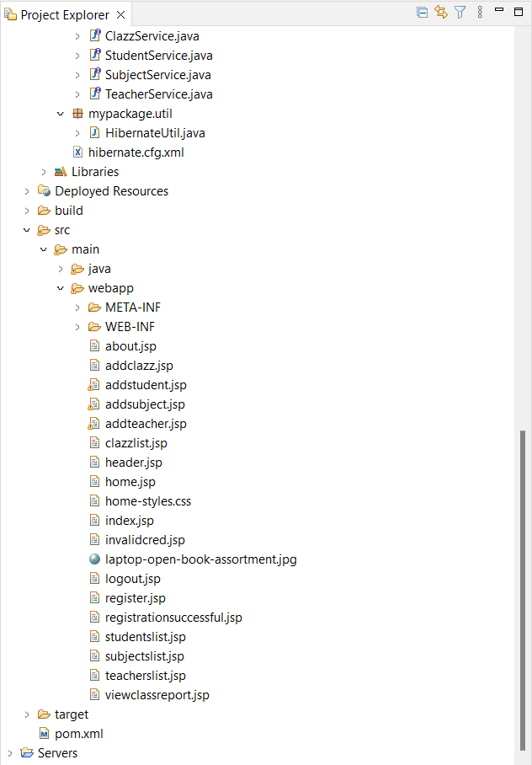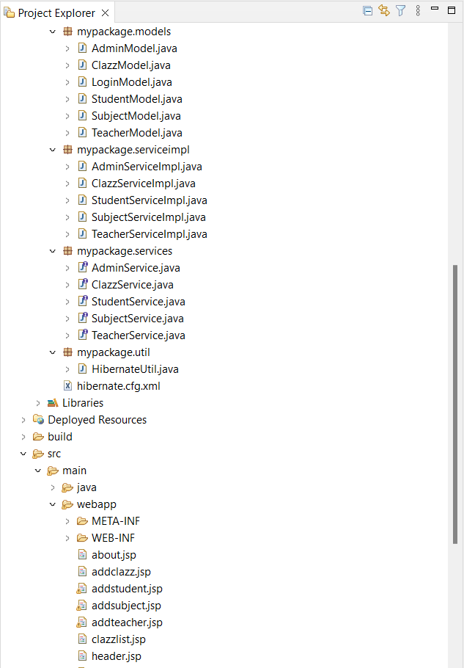

# Flowchart of the application:

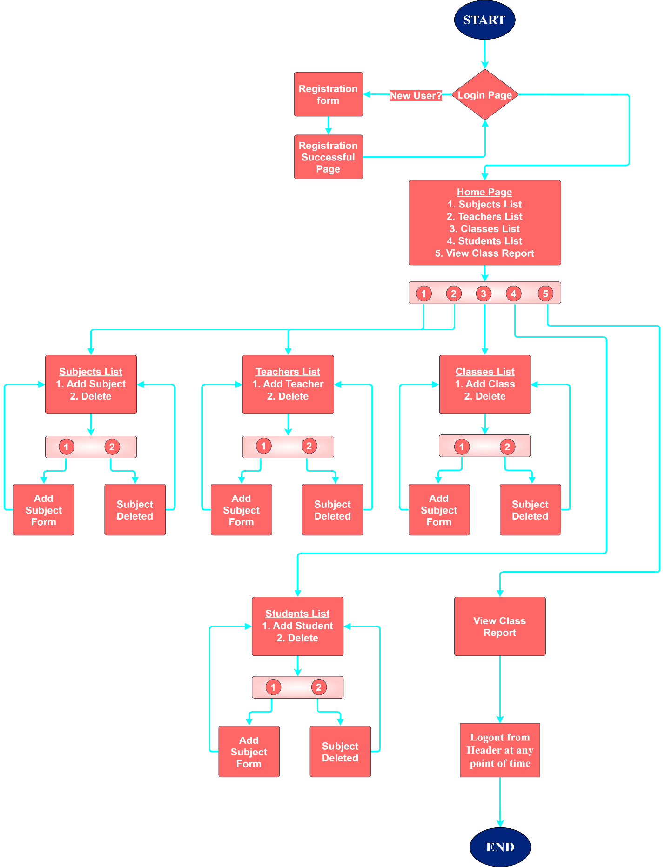



# Demonstration of product capabilities, appearance, and user interactions:

The following sections have been organized to highlight the project's appearance and user interactions in order to demonstrate the capabilities of the product:

1. Creating a Dynamic Web Project in Eclipse
2. Setting up HibernateUtil.java & hibernate.cfg.xml
3. Creating Entity classes
4. Creating DAO interfaces
5. Creating DAOImpl classes
6. Creating .jsp files
7. Creating Controller java servlets
8. Creating Model classes
9. Creating Service interfaces
10. Creating ServiceImpl classes
11. Creating Filter
12. Pushing the code to GitHub Repository.
13. **Creating a Dynamic Web Project in Eclipse**

* Open Eclipse IDE.
* Go to File 🡪 New 🡪 Others 🡪 Dynamic Web Project.
* Give the project name ‘LearnersAcademy’, check if the dynamic web module version is above 3.0, and click Finish.
* Right-click on the ‘LearnersAcademy’ project in project explorer 🡪 Configure 🡪 Convert to Maven Project 🡪 Give Group Id as mypackage and Artifact Id as ‘LearnersAcademy’ 🡪 Click Finish.
* Add Maven Dependencies in the pom.xml file that appears after converting the project to a Maven Project.

**Pom.xml file:**

<project xmlns="http://maven.apache.org/POM/4.0.0" xmlns:xsi="http://www.w3.org/2001/XMLSchema-instance" xsi:schemaLocation="http://maven.apache.org/POM/4.0.0 https://maven.apache.org/xsd/maven-4.0.0.xsd">

<modelVersion>4.0.0</modelVersion>

<groupId>LearnersAcademy</groupId>

<artifactId>LearnersAcademy</artifactId>

<version>0.0.1-SNAPSHOT</version>

<packaging>war</packaging>

<dependencies>

<dependency>

<groupId>javax.servlet</groupId>

<artifactId>javax.servlet-api</artifactId>

<version>4.0.1</version>

<scope>provided</scope>

</dependency>

<dependency>

<groupId>mysql</groupId>

<artifactId>mysql-connector-java</artifactId>

<version>8.0.33</version>

</dependency>

<dependency>

<groupId>org.hibernate</groupId>

<artifactId>hibernate-core</artifactId>

<version>5.6.14.Final</version>

</dependency>

<dependency>

<groupId>jstl</groupId>

<artifactId>jstl</artifactId>

<version>1.2</version>

</dependency>

</dependencies>

<build>

<plugins>

<plugin>

<artifactId>maven-compiler-plugin</artifactId>

<version>3.8.1</version>

<configuration>

<source>1.8</source>

<target>1.8</target>

</configuration>

</plugin>

<plugin>

<artifactId>maven-war-plugin</artifactId>

<version>3.2.3</version>

</plugin>

</plugins>

</build>

</project>

1. **Setting up HibernateUtil.java & hibernate.cfg.xml**

* Create a package ‘mypackage.util’ in Java Resources.
* Create a java class HibernateUtil.java in mypackage.util.

**HibernateUtil.java**

package mypackage.util;

import org.hibernate.SessionFactory;

import org.hibernate.cfg.Configuration;

import mypackage.entities.Admin;

import mypackage.entities.Clazz;

import mypackage.entities.Student;

import mypackage.entities.Subject;

import mypackage.entities.Teacher;

public class HibernateUtil {

static SessionFactory sessionFactory = null;

public static SessionFactory buildSessionFactory() {

if(sessionFactory != null) {

return sessionFactory;

}

// STEP 1: Create Configuration Object

Configuration cfg = new Configuration().configure("hibernate.cfg.xml").addAnnotatedClass(Student.class)

.addAnnotatedClass(Subject.class).addAnnotatedClass(Clazz.class).addAnnotatedClass(Teacher.class).addAnnotatedClass(Admin.class);

sessionFactory = cfg.buildSessionFactory();

return sessionFactory;

}

}

**Hibernate.cfg.xml**

<?xml version="1.0" encoding="UTF-8"?>

<!DOCTYPE hibernate-configuration PUBLIC

"-//Hibernate/Hibernate Configuration DTD 3.0//EN"

"http://www.hibernate.org/dtd/hibernate-configuration-3.0.dtd">

<hibernate-configuration>

<session-factory>

<property name="hibernate.connection.driver_class">com.mysql.jdbc.Driver</property>

<property name="hibernate.connection.url">jdbc:mysql://localhost:3306/priya</property>

<property name="hibernate.connection.username">root</property>

<property name="hibernate.connection.password">Priya@0456</property>

<property name="hibernate.show_sql">true</property>

<property name="hibernate.format_sql">true</property>

<property name="hbm2ddl.auto">update</property>

</session-factory>

</hibernate-configuration>

1. **Creating Entity classes**

* Create a package ‘mypackage.entities’ in Java Resources.
* Create java classes Admin.java, Clazz.java, Student.java, Subject.java, Teacher.java files in mypackage.entities.
* Define data models, add ORM annotations and map relationships.

**Admin.java**

package mypackage.entities;

import java.util.HashSet;

import java.util.Set;

import javax.persistence.Column;

import javax.persistence.Entity;

import javax.persistence.FetchType;

import javax.persistence.GeneratedValue;

import javax.persistence.GenerationType;

import javax.persistence.Id;

import javax.persistence.OneToMany;

import javax.persistence.Table;

@Entity

@Table(name = "Admin")

public class Admin {

@Id

@GeneratedValue(strategy = GenerationType.IDENTITY)

@Column(name = "admin_id")

private int id;

@Column(name = "admin_username")

private String username;

@Column(name = "admin_password")

private String password;

@OneToMany(mappedBy = "admin", fetch = FetchType.EAGER)

private Set<Subject> subjects = new HashSet<>();

@OneToMany(mappedBy = "admin", fetch = FetchType.EAGER)

private Set<Clazz> clazzes = new HashSet<>();

@OneToMany(mappedBy = "admin", fetch = FetchType.EAGER)

private Set<Teacher> teachers = new HashSet<>();

@OneToMany(mappedBy = "admin", fetch = FetchType.EAGER)

private Set<Student> students = new HashSet<>();

//Helper Methods

public void addSubject(Subject subject) {

subjects.add(subject);

}

public void addClazz(Clazz clazz) {

clazzes.add(clazz);

}

public void addTeacher(Teacher teacher) {

teachers.add(teacher);

}

public void addStudent(Student student) {

students.add(student);

}

//Getters and Setters

public int getId() {

return id;

}

public void setId(int id) {

this.id = id;

}

public String getUsername() {

return username;

}

public void setUsername(String username) {

this.username = username;

}

public String getPassword() {

return password;

}

public void setPassword(String password) {

this.password = password;

}

public Set<Subject> getSubjects() {

return subjects;

}

public void setSubjects(Set<Subject> subjects) {

this.subjects = subjects;

}

public Set<Clazz> getClazzes() {

return clazzes;

}

public void setClazzes(Set<Clazz> clazzes) {

this.clazzes = clazzes;

}

public Set<Teacher> getTeachers() {

return teachers;

}

public void setTeachers(Set<Teacher> teachers) {

this.teachers = teachers;

}

public Set<Student> getStudents() {

return students;

}

public void setStudents(Set<Student> students) {

this.students = students;

}

}

**Clazz.java**

package mypackage.entities;

import java.util.HashSet;

import java.util.Set;

import javax.persistence.CascadeType;

import javax.persistence.Column;

import javax.persistence.Entity;

import javax.persistence.GeneratedValue;

import javax.persistence.GenerationType;

import javax.persistence.Id;

import javax.persistence.JoinColumn;

import javax.persistence.ManyToMany;

import javax.persistence.ManyToOne;

import javax.persistence.OneToMany;

import javax.persistence.Table;

@Entity

@Table(name = "Clazz")

public class Clazz {

@Id

@GeneratedValue(strategy = GenerationType.IDENTITY)

@Column(name = "clazz_id")

private int clazz_id;

@Column(name = "clazz_name")

private String clazz_name;

@OneToMany(mappedBy = "clazz", cascade = CascadeType.ALL)

private Set<Subject> subjects = new HashSet<>();

@ManyToMany(mappedBy = "clazzes")

private Set<Teacher> teachers = new HashSet<>();

@ManyToOne(cascade = { CascadeType.PERSIST, CascadeType.MERGE })

@JoinColumn(name = "aid")

private Admin admin;

@OneToMany(mappedBy = "clazz", cascade = CascadeType.ALL)

private Set<Student> students = new HashSet<>();

// Helper Methods

public void addStudent(Student student) {

this.students.add(student);

}

public void addSubject(Subject subject) {

this.subjects.add(subject);

}

public void addTeacher(Teacher teacher) {

this.teachers.add(teacher);

}

// Getters and Setters

public int getClazz_id() {

return clazz_id;

}

public void setClazz_id(int clazz_id) {

this.clazz_id = clazz_id;

}

public String getClazz_name() {

return clazz_name;

}

public void setClazz_name(String clazz_name) {

this.clazz_name = clazz_name;

}

public Set<Subject> getSubjects() {

return subjects;

}

public void setSubjects(Set<Subject> subjects) {

this.subjects = subjects;

}

public Set<Teacher> getTeachers() {

return teachers;

}

public void setTeachers(Set<Teacher> teachers) {

this.teachers = teachers;

}

public Admin getAdmin() {

return admin;

}

public void setAdmin(Admin admin) {

this.admin = admin;

}

public Set<Student> getStudents() {

return students;

}

public void setStudents(Set<Student> students) {

this.students = students;

}

}

**Student.java**

package mypackage.entities;

import javax.persistence.CascadeType;

import javax.persistence.Column;

import javax.persistence.Entity;

import javax.persistence.GeneratedValue;

import javax.persistence.GenerationType;

import javax.persistence.Id;

import javax.persistence.JoinColumn;

import javax.persistence.ManyToOne;

import javax.persistence.OneToOne;

import javax.persistence.Table;

@Entity

@Table(name = "Student")

public class Student {

@Id

@GeneratedValue(strategy = GenerationType.IDENTITY)

@Column(name = "student_id")

private int student_id;

@Column(name = "student_name")

private String student_name;

@Column(name = "student_address")

private String address;

@OneToOne(cascade = CascadeType.ALL)

@JoinColumn(name = "cid")

private Clazz clazz;

@ManyToOne(cascade = { CascadeType.PERSIST, CascadeType.MERGE })

@JoinColumn(name = "aid")

private Admin admin;

// Helper Method

public String getClazzName() {

if (clazz != null) {

return clazz.getClazz_name();

}

return "";

}

// Getters and Setters

public int getStudent_id() {

return student_id;

}

public void setStudent_id(int student_id) {

this.student_id = student_id;

}

public String getStudent_name() {

return student_name;

}

public void setStudent_name(String student_name) {

this.student_name = student_name;

}

public String getAddress() {

return address;

}

public void setAddress(String address) {

this.address = address;

}

public Clazz getClazz() {

return clazz;

}

public void setClazz(Clazz clazz) {

this.clazz = clazz;

}

public Admin getAdmin() {

return admin;

}

public void setAdmin(Admin admin) {

this.admin = admin;

}

}

**Subject.java**

package mypackage.entities;

import javax.persistence.CascadeType;

import javax.persistence.Column;

import javax.persistence.Entity;

import javax.persistence.GeneratedValue;

import javax.persistence.GenerationType;

import javax.persistence.Id;

import javax.persistence.JoinColumn;

import javax.persistence.ManyToOne;

import javax.persistence.Table;

@Entity

@Table(name = "Subject")

public class Subject {

@Id

@GeneratedValue(strategy = GenerationType.IDENTITY)

@Column(name = "subject_id")

private int subject_id;

@Column(name = "subject_name")

private String subject_name;

@Column(name = "subject_level")

private String subject_level;

@ManyToOne(cascade = { CascadeType.MERGE, CascadeType.PERSIST, CascadeType.REFRESH })

@JoinColumn(name = "cid")

private Clazz clazz;

@ManyToOne(cascade = CascadeType.MERGE)

@JoinColumn(name = "aid")

private Admin admin;

// Helper Method

public String getClazzName() {

if (clazz != null) {

return clazz.getClazz_name();

}

return "";

}

// Getters and Setters

public int getSubject_id() {

return subject_id;

}

public void setSubject_id(int subject_id) {

this.subject_id = subject_id;

}

public String getSubject_name() {

return subject_name;

}

public void setSubject_name(String subject_name) {

this.subject_name = subject_name;

}

public String getSubject_level() {

return subject_level;

}

public void setSubject_level(String subject_level) {

this.subject_level = subject_level;

}

public Clazz getClazz() {

return clazz;

}

public void setClazz(Clazz clazz) {

this.clazz = clazz;

}

public Admin getAdmin() {

return admin;

}

public void setAdmin(Admin admin) {

this.admin = admin;

}

}

**Teacher.java**

package mypackage.entities;

import java.util.HashSet;

import java.util.Set;

import javax.persistence.CascadeType;

import javax.persistence.Column;

import javax.persistence.Entity;

import javax.persistence.GeneratedValue;

import javax.persistence.GenerationType;

import javax.persistence.Id;

import javax.persistence.JoinColumn;

import javax.persistence.JoinTable;

import javax.persistence.ManyToMany;

import javax.persistence.ManyToOne;

import javax.persistence.Table;

@Entity

@Table(name = "Teacher")

public class Teacher {

@Id

@GeneratedValue(strategy = GenerationType.IDENTITY)

@Column(name = "teacher_id")

private int teacher_id;

@Column(name = "teacher_name")

private String teacher_name;

@Column(name = "teacher_qual")

private String teacher_qual;

@ManyToMany(cascade = { CascadeType.PERSIST, CascadeType.MERGE })

@JoinTable(

name = "teacher_class",

joinColumns = { @JoinColumn(name = "teacher_id") },

inverseJoinColumns = { @JoinColumn(name = "class_id") }

)

private Set<Clazz> clazzes = new HashSet<>();

@ManyToOne(cascade = { CascadeType.PERSIST, CascadeType.MERGE })

@JoinColumn(name = "aid", referencedColumnName = "admin_id")

private Admin admin;

// Helper Method

public void addClass(Clazz clazz) {

clazzes.add(clazz);

}

// Getters and Setters

public int getTeacher_id() {

return teacher_id;

}

public void setTeacher_id(int teacher_id) {

this.teacher_id = teacher_id;

}

public String getTeacher_name() {

return teacher_name;

}

public void setTeacher_name(String teacher_name) {

this.teacher_name = teacher_name;

}

public String getTeacher_qual() {

return teacher_qual;

}

public void setTeacher_qual(String teacher_qual) {

this.teacher_qual = teacher_qual;

}

public String getClazzes() {

StringBuffer sb = new StringBuffer();

if(clazzes != null && clazzes.size()>0)

{

for(Clazz c : clazzes)

{

sb.append(c.getClazz_name() + ",");

}

}

return sb.toString();

}

public void setClazzes(Set<Clazz> clazzes) {

this.clazzes = clazzes;

}

public Admin getAdmin() {

return admin;

}

public void setAdmin(Admin admin) {

this.admin = admin;

}

}

1. **Creating DAO interfaces**

* Create a package ‘mypackage.dao’ in Java Resources.
* Create interfaces AdminDao.java, ClazzDao.java, StudentDao.java, SubjectDao .java, TeacherDao.java.
* Define CRUD operations required for each entity.

**AdminDao.java**

package mypackage.dao;

import mypackage.entities.Admin;

public interface AdminDao {

void insert(Admin admin);

Admin getAdmin(String username, String password);

}

**ClazzDao.java**

package mypackage.dao;

import java.util.List;

import mypackage.entities.Clazz;

public interface ClazzDao {

void add(Clazz clazz) throws Exception;

void delete(int id) throws Exception;

Clazz getClazzById(int cid);

List<Clazz> getAll();

Clazz getByName(String className);

}

**StudentDao.java**

package mypackage.dao;

import java.util.List;

import mypackage.entities.Clazz;

import mypackage.entities.Student;

public interface StudentDao {

void add(Student student) throws Exception;

void delete(int sid) throws Exception;

List<Student> getAll();

List<Student> getByClass(Clazz clazz);

}

**SubjectDao .java**

package mypackage.dao;

import java.util.List;

import mypackage.entities.Clazz;

import mypackage.entities.Subject;

public interface SubjectDao {

void add(Subject subject) throws Exception;

void delete(int sid) throws Exception;

void update(Subject subject) throws Exception;

List<Subject> getAll();

Subject getSubjectById(int subjectId);

List<Subject> getByClass(Clazz clazz);

}

**TeacherDao.java**

package mypackage.dao;

import java.util.List;

import mypackage.entities.Teacher;

public interface TeacherDao {

void add(Teacher teacher) throws Exception;

void delete(int tid) throws Exception;

List<Teacher> getAll();

}

1. **Creating DAOImpl classes**

* Create a package ‘mypackage.daoimpl’ in Java Resources.
* Create java classes AdminDaoImpl.java, ClazzDaoImpl.java, StudentDaoImpl .java, SubjectDaoImpl.java and TeacherDaoImpl.java.
* Provide concrete implementations for the CRUD operations and other data access methods defined in the DAO interface.

**AdminDaoImpl.java**

package mypackage.daoimpl;

import org.hibernate.Query;

import org.hibernate.Session;

import org.hibernate.SessionFactory;

import org.hibernate.Transaction;

import mypackage.dao.AdminDao;

import mypackage.entities.Admin;

import mypackage.util.HibernateUtil;

public class AdminDaoImpl implements AdminDao {

@Override

public void insert(Admin admin) {

SessionFactory sessionFactory = HibernateUtil.buildSessionFactory();

Session session = sessionFactory.openSession();

Transaction tx = null;

try {

tx = session.beginTransaction();

session.save(admin);

tx.commit();

} catch (Exception e) {

e.printStackTrace();

} finally {

session.close();

}

}

@Override

public Admin getAdmin(String username, String password) {

SessionFactory sessionFactory = null;

Session session = null;

Query<Admin> query = null;

Admin admin = null;

try {

sessionFactory = HibernateUtil.buildSessionFactory();

session = sessionFactory.openSession();

query = session.createQuery("select a from mypackage.entities.Admin a where a.username = ?1 and a.password = ?2");

query.setParameter(1, username); // Set the value for the first ordinal parameter

query.setParameter(2, password);

admin = query.uniqueResult();

} catch (Exception e) {

e.printStackTrace();

}

finally {

session.close();

}

return admin;

}

}

**ClazzDaoImpl.java**

package mypackage.daoimpl;

import java.util.List;

import org.hibernate.Query;

import org.hibernate.Session;

import org.hibernate.SessionFactory;

import org.hibernate.Transaction;

import mypackage.dao.ClazzDao;

import mypackage.entities.Clazz;

import mypackage.util.HibernateUtil;

public class ClazzDaoImpl implements ClazzDao {

@Override

public void add(Clazz clazz) throws Exception {

SessionFactory sessionFactory = HibernateUtil.buildSessionFactory();

Session session = sessionFactory.openSession();

Transaction tx = null;

try {

tx = session.beginTransaction();

session.save(clazz);

tx.commit();

} catch (Exception e) {

if (tx != null) {

tx.rollback();

}

throw new Exception("Failed to add teacher.", e);

} finally {

session.close();

}

}

@Override

public void delete(int id) throws Exception {

SessionFactory sessionFactory = HibernateUtil.buildSessionFactory();

Session session = sessionFactory.openSession();

Transaction tx = null;

try {

tx = session.beginTransaction();

Clazz clazz = session.get(Clazz.class, id);

session.delete(clazz);

tx.commit();

} catch (Exception e) {

if (tx != null) {

tx.rollback();

}

throw new Exception("Failed to delete teacher.", e);

} finally {

session.close();

}

}

@Override

public List<Clazz> getAll() {

SessionFactory sessionFactory = HibernateUtil.buildSessionFactory();

Session session = sessionFactory.openSession();

Query<Clazz> query = session.createQuery("select c from mypackage.entities.Clazz c");

return query.list();

}

@Override

public Clazz getClazzById(int cid) {

SessionFactory sessionFactory = HibernateUtil.buildSessionFactory();

Session session = sessionFactory.openSession();

Query<Clazz> query = session.createQuery("select c from mypackage.entities.Clazz c where c.clazz_id = ?1");

query.setParameter(1, cid);

Clazz result = (Clazz) query.uniqueResult();

session.close();

return result;

}

@Override

public Clazz getByName(String className) {

SessionFactory sessionFactory = HibernateUtil.buildSessionFactory();

Session session = sessionFactory.openSession();

Query<Clazz> query = session.createQuery("SELECT c FROM Clazz c WHERE c.className = :className");

query.setParameter("className", className);

Clazz result = query.uniqueResult();

session.close();

return result;

}

}

**StudentDaoImpl .java**

package mypackage.daoimpl;

import java.util.List;

import org.hibernate.Query;

import org.hibernate.Session;

import org.hibernate.SessionFactory;

import org.hibernate.Transaction;

import mypackage.dao.StudentDao;

import mypackage.entities.Clazz;

import mypackage.entities.Student;

import mypackage.util.HibernateUtil;

public class StudentDaoImpl implements StudentDao {

@Override

public void add(Student student) throws Exception {

SessionFactory sessionFactory = HibernateUtil.buildSessionFactory();

Session session = sessionFactory.openSession();

Transaction tx = null;

try {

tx = session.beginTransaction();

session.save(student);

tx.commit();

} catch (Exception e) {

if (tx != null) {

tx.rollback();

}

throw new Exception("Failed to add teacher.", e);

} finally {

session.close();

}

}

@Override

public void delete(int sid) throws Exception {

SessionFactory sessionFactory = HibernateUtil.buildSessionFactory();

Session session = sessionFactory.openSession();

Transaction tx = null;

try {

tx = session.beginTransaction();

Student student = session.get(Student.class, sid);

session.delete(student);

tx.commit();

} catch (Exception e) {

if (tx != null) {

tx.rollback();

}

throw new Exception("Failed to delete teacher.", e);

} finally {

session.close();

}

}

@Override

public List<Student> getAll() {

SessionFactory sessionFactory = HibernateUtil.buildSessionFactory();

Session session = sessionFactory.openSession();

Query<Student> query = session.createQuery("select s from mypackage.entities.Student s");

return query.list();

}

@Override

public List<Student> getByClass(Clazz clazz) {

SessionFactory sessionFactory = HibernateUtil.buildSessionFactory();

Session session = sessionFactory.openSession();

Query<Student> query = session.createQuery("SELECT s FROM Student s WHERE s.clazz = :clazz");

query.setParameter("clazz", clazz);

List<Student> students = query.list();

session.close();

return students;

}

}

**SubjectDaoImpl.java**

package mypackage.daoimpl;

import java.util.List;

import org.hibernate.Query;

import org.hibernate.Session;

import org.hibernate.SessionFactory;

import org.hibernate.Transaction;

import mypackage.dao.SubjectDao;

import mypackage.entities.Clazz;

import mypackage.entities.Subject;

import mypackage.util.HibernateUtil;

public class SubjectDaoImpl implements SubjectDao {

@Override

public void add(Subject subject) throws Exception {

SessionFactory sessionFactory = HibernateUtil.buildSessionFactory();

Session session = sessionFactory.openSession();

Transaction tx = null;

try {

tx = session.beginTransaction();

session.save(subject);

tx.commit();

} catch (Exception e) {

if (tx != null) {

tx.rollback();

}

throw new Exception("Failed to add subject.", e);

} finally {

session.close();

}

}

@Override

public void delete(int sid) throws Exception {

SessionFactory sessionFactory = HibernateUtil.buildSessionFactory();

Session session = sessionFactory.openSession();

Transaction tx = null;

try {

tx = session.beginTransaction();

Subject subject = session.get(Subject.class, sid);

session.delete(subject);

tx.commit();

} catch (Exception e) {

if (tx != null) {

tx.rollback();

}

throw new Exception("Failed to delete subject.", e);

} finally {

session.close();

}

}

@Override

public void update(Subject subject) throws Exception {

SessionFactory sessionFactory = HibernateUtil.buildSessionFactory();

Session session = sessionFactory.openSession();

Transaction tx = null;

try {

tx = session.beginTransaction();

Subject sub = session.get(Subject.class, subject.getSubject_id());

session.update(sub);

tx.commit();

} catch (Exception e) {

if (tx != null) {

tx.rollback();

}

throw new Exception("Failed to update subject.", e);

} finally {

session.close();

}

}

@Override

public List<Subject> getAll() {

SessionFactory sessionFactory = HibernateUtil.buildSessionFactory();

Session session = sessionFactory.openSession();

Query<Subject> query = session.createQuery("select s from mypackage.entities.Subject s");

return query.list();

}

@Override

public Subject getSubjectById(int subjectId) {

SessionFactory sessionFactory = HibernateUtil.buildSessionFactory();

Session session = sessionFactory.openSession();

Query<Subject> query = session.createQuery("select s from mypackage.entities.Subject s where s.subject_id = ?1");

query.setParameter(1, subjectId);

Subject result = (Subject) query.uniqueResult();

session.close();

return result;

}

@Override

public List<Subject> getByClass(Clazz clazz) {

SessionFactory sessionFactory = HibernateUtil.buildSessionFactory();

Session session = sessionFactory.openSession();

Query<Subject> query = session.createQuery("SELECT s FROM Subject s WHERE s.clazz = :clazz");

query.setParameter("clazz", clazz);

List<Subject> subjects = query.list();

session.close();

return subjects;

}

}

**TeacherDaoImpl.java**

package mypackage.daoimpl;

import java.util.List;

import org.hibernate.Query;

import org.hibernate.Session;

import org.hibernate.SessionFactory;

import org.hibernate.Transaction;

import mypackage.dao.TeacherDao;

import mypackage.entities.Teacher;

import mypackage.util.HibernateUtil;

public class TeacherDaoImpl implements TeacherDao{

@Override

public void add(Teacher teacher) throws Exception {

SessionFactory sessionFactory = HibernateUtil.buildSessionFactory();

Session session = sessionFactory.openSession();

Transaction tx = null;

try {

tx = session.beginTransaction();

session.save(teacher);

tx.commit();

} catch (Exception e) {

if (tx != null) {

tx.rollback();

}

throw new Exception("Failed to add teacher.", e);

} finally {

session.close();

}

}

@Override

public void delete(int tid) throws Exception {

SessionFactory sessionFactory = HibernateUtil.buildSessionFactory();

Session session = sessionFactory.openSession();

Transaction tx = null;

try {

tx = session.beginTransaction();

Teacher teacher = session.get(Teacher.class, tid);

session.delete(teacher);

tx.commit();

} catch (Exception e) {

if (tx != null) {

tx.rollback();

}

throw new Exception("Failed to delete teacher.", e);

} finally {

session.close();

}

}

@Override

public List<Teacher> getAll() {

SessionFactory sessionFactory = HibernateUtil.buildSessionFactory();

Session session = sessionFactory.openSession();

Query<Teacher> query = session.createQuery("select t from mypackage.entities.Teacher t");

return query.list();

}

}

1. **Creating .jsp files**

* Create .jsp files in webapp folder in src.
* Create index.jsp file which serves as the entry point of the application and other .jsp files for creating views in the web application.
* Create .css files or embed the CSS styles in .jsp file itself.

**index.jsp**

<%@ page language="java" contentType="text/html; charset=UTF-8"

pageEncoding="UTF-8"%>

<!DOCTYPE html>

<html>

<head>

<style>

.welcome {

text-align: center;

padding-bottom: 20px;

}

fieldset {

text-align: center;

border: 2px #01257D solid;

}

legend {

text-align: center;

color: #01257D;

font-size: 20px;

font-weight: 700;

}

.option {

font-size: 12px;

padding-top: 8px;

}

</style>

<meta charset="UTF-8">

<title>Login Page</title>

</head>

<body>

<%@ include file="header.jsp"%>

<div class="welcome">

<h1>Learner's Academy</h1>

</div>

<form action="logincontroller" method="post" style = "width: 400px; margin: 0px auto;">

<fieldset>

<legend>Admin Login</legend><br>

Username : <input type="text" id="username" name="username" required><br><br>

Password : <input type="password" id="password" name="password" required><br><br>

<input type="submit" value="Submit">

<div class="option">

Not a registered user?<a href="register.jsp">Click here</a>

</div>

</fieldset>

</form>

</body>

</html>

**about.jsp**

<%@ page language="java" contentType="text/html; charset=UTF-8" pageEncoding="UTF-8"%>

<!DOCTYPE html>

<html>

<head>

<style>

h1 {

color: #01257D;

text-align: center;

}

.details-container {

width: 600px;

color: #01257D;

text-align: justify;

padding-left: 618px;

}

.details {

width: 300px;

word-wrap: break-word;

text-align: center;

}

</style>

<meta charset="UTF-8">

<title>About Developer</title>

</head>

<body>

<%@ include file="header.jsp"%>

<h1> About Developer </h1>

<div class="details-container">

<div class="details">

<p>

Name : Tejeswi Devi Priya<br><br>

Email ID : priyapillarisetty19@gmail.com

</p>

<p>

Thank you for exploring the Learner's Academy Backend Admin Portal.

</p>

<p>

Should you have any queries or feedback regarding the portal, please feel free to reach out to me at the provided email address.

</p>

</div>

</div>

</body>

</html>

**addclazz.jsp**

<%@ page language="java" contentType="text/html; charset=UTF-8"

pageEncoding="UTF-8"%>

<!DOCTYPE html>

<html>

<head>

<style>

form {

padding-top: 50px;

}

fieldset {

text-align: center;

border: 2px #01257D solid;

overflow: auto;

}

legend {

text-align: center;

color: #01257D;

font-size: 20px;

font-weight: 700;

}

label {

display: inline-block;

width: 80px;

text-align: right;

font-weight: 600;

color: #01257D;

margin-right: 5px;

}

input[type="text"] {

width: 167px;

}

</style>

<meta charset="UTF-8">

<title>Add Clazz</title>

</head>

<body>

<%@ include file="header.jsp"%>

<form action="clazzcontroller" method="post" style="width: 400px; margin: 0px auto;">

<fieldset>

<legend>Add Clazz form</legend><br>

<label>Name : </label><input type="text" name="clazzname" required><br><br>

<input type="submit" value="Submit">

</fieldset>

</form>

</body>

</html>

**addstudent.jsp**

<%@ page language="java" contentType="text/html; charset=UTF-8"

pageEncoding="UTF-8"%>

<!DOCTYPE html>

<html>

<%@ page import="java.util.List"%>

<%@ page import="mypackage.entities.Clazz"%>

<%@ page import="mypackage.dao.ClazzDao"%>

<%@ page import="mypackage.daoimpl.ClazzDaoImpl"%>

<head>

<style>

form {

padding-top: 50px;

}

fieldset {

text-align: center;

border: 2px #01257D solid;

overflow: auto;

}

legend {

text-align: center;

color: #01257D;

font-size: 20px;

font-weight: 700;

}

label {

display: inline-block;

width: 120px;

text-align: right;

font-weight: 600;

color: #01257D;

margin-right: 5px;

}

input[type="text"], select {

width: 167px;

}

select option[disabled] {

text-align: center;

padding: 0;

}

</style>

<meta charset="UTF-8">

<title>Add Student</title>

</head>

<body>

<%@ include file="header.jsp"%>

<%

ClazzDao clazzDao = new ClazzDaoImpl();

List<Clazz> clazzes = clazzDao.getAll();

request.setAttribute("clazzes", clazzes);

%>

<form action="studentcontroller" method="post" style="width: 400px; margin: 0px auto;">

<fieldset>

<legend>Add Student form</legend><br>

<label>Name : </label><input type="text" name="studentname" required><br><br>

<label>Address : </label><input type="text" name="studentaddress" required>

<p>

<label> Assign Class : </label> <select name="clazzname" id="clazzname" required>

<option disabled selected value>-- select class --</option>

<% for (Clazz clazz : clazzes) { %>

<option value="<%= clazz.getClazz_id() %>"><%= clazz.getClazz_name() %></option>

<% } %>

</select>

</p>

<input type="submit" value="Submit">

</fieldset>

</form>

</body>

</html>

**addsubject.jsp**

<%@page import="mypackage.serviceimpl.ClazzServiceImpl"%>

<%@ page language="java" contentType="text/html; charset=UTF-8"

pageEncoding="UTF-8"%>

<!DOCTYPE html>

<html>

<%@ page import="java.util.List"%>

<%@ page import="mypackage.entities.Clazz"%>

<%@ page import="mypackage.dao.ClazzDao"%>

<%@ page import="mypackage.daoimpl.ClazzDaoImpl"%>

<head>

<style>

form {

padding-top: 50px;

}

fieldset {

text-align: center;

border: 2px #01257D solid;

overflow: auto;

}

legend {

text-align: center;

color: #01257D;

font-size: 20px;

font-weight: 700;

}

label {

display: inline-block;

width: 120px;

text-align: right;

font-weight: 600;

color: #01257D;

margin-right: 5px;

}

input[type="text"], select {

width: 167px;

}

select option[disabled] {

text-align: center;

padding: 0;

}

</style>

<meta charset="UTF-8">

<title>Add Subject</title>

</head>

<body>

<%@ include file="header.jsp"%>

<%

ClazzDao clazzDao = new ClazzDaoImpl();

List<Clazz> clazzes = clazzDao.getAll();

request.setAttribute("clazzes", clazzes);

%>

<form action="subjectcontroller" method="post"

style="width: 400px; margin: 0px auto;">

<fieldset>

<legend>Add Subject form</legend>

<br> <label>Name: </label><input type="text" name="subjectname"

required>

<p>

<label>Level: </label> <select name="subjectlevel" id="subjectlevel"

required>

<option disabled selected value>-- select level --</option>

<option value="Level I">Level I</option>

<option value="Level II">Level II</option>

</select>

</p>

<p>

<label> Assign Class : </label> <select name="clazzname" id="clazzname"

required>

<option disabled selected value>-- select class --</option>

<% for (Clazz clazz : clazzes) { %>

<option value="<%= clazz.getClazz_id() %>"><%= clazz.getClazz_name() %></option>

<% } %>

</select>

</p>

<input type="submit" value="Submit">

</fieldset>

</form>

</body>

</html>

**addteacher.jsp**

<%@ page language="java" contentType="text/html; charset=UTF-8"

pageEncoding="UTF-8"%>

<!DOCTYPE html>

<html>

<%@ page import="java.util.List"%>

<%@ page import="mypackage.entities.Clazz" %>

<%@ page import="mypackage.dao.ClazzDao" %>

<%@ page import="mypackage.daoimpl.ClazzDaoImpl" %>

<head>

<style>

form {

padding-top: 50px;

}

fieldset {

text-align: center;

border: 2px #01257D solid;

overflow: auto;

}

legend {

text-align: center;

color: #01257D;

font-size: 20px;

font-weight: 700;

}

label {

display: inline-block;

width: 120px;

text-align: right;

font-weight: 600;

color: #01257D;

margin-right: 5px;

}

input[type="text"], select {

width: 167px;

}

select option[disabled] {

text-align: center;

padding: 0;

}

</style>

<meta charset="UTF-8">

<title>Add Teacher</title>

</head>

<body>

<%@ include file="header.jsp"%>

<%

ClazzDao clazzDao = new ClazzDaoImpl();

List<Clazz> clazzes = clazzDao.getAll();

request.setAttribute("clazzes", clazzes);

%>

<form action="teachercontroller" method="post" style="width: 400px; margin: 0px auto;">

<fieldset>

<legend>Add Teacher form</legend><br>

<label>Name : </label><input type="text" name="teachername" required>

<p>

<label>Qualification : </label> <select name="qualification" id="qualification" required>

<option disabled selected value>-- select qualification --</option>

<option value="BTech">BTech</option>

<option value="MTech">MTech</option>

</select>

</p>

<p>

<label> Assign Class : </label> <select name="clazzname" id="clazzname" required>

<option disabled selected value>-- select class --</option>

<% for (Clazz clazz : clazzes) { %>

<option value="<%= clazz.getClazz_id() %>"><%= clazz.getClazz_name() %></option>

<% } %>

</select>

</p>

<input type="submit" value="Submit">

</fieldset>

</form>

</body>

</html>

**clazzlist.jsp**

<%@ page language="java" contentType="text/html; charset=UTF-8"

pageEncoding="UTF-8"%>

<!DOCTYPE html>

<html>

<%@ page import="java.util.List" %>

<%@ page import="mypackage.entities.Clazz" %>

<%@ page import="mypackage.dao.ClazzDao" %>

<%@ page import="mypackage.daoimpl.ClazzDaoImpl" %>

<head>

<style>

table {

border-collapse: collapse;

width: 50%;

margin: auto;

}

th, td {

border: 2px #01257D solid;

text-align: center;

}

th {

color: #333;

font-weight: bold;

}

.head1 {

color: #01257D;

padding-top: 10px;

padding-bottom: 10px;

text-align: center;

}

</style>

<meta charset="UTF-8">

<title>Class List</title>

</head>

<body>

<%@ include file="header.jsp"%>

<%

ClazzDao clazzDao = new ClazzDaoImpl();

List<Clazz> clazzes = clazzDao.getAll();

request.setAttribute("clazzes", clazzes);

%>

<div class="head1">

<h1> Class List </h1>

</div>

<table>

<tr>

<th> Class ID </th>

<th> Class Name </th>

<th> Actions </th>

</tr>

<% int sequence = 1; %>

<%

for(Clazz clazz : clazzes) {

%>

<tr>

<td><%= sequence %></td>

<td><%= clazz.getClazz_name() %></td>

<td>

<form action="clazzlist.jsp" method="POST">

<input type="hidden" name="cid" value="<%= clazz.getClazz_id() %>">

<button type="submit" name="action" value="delete">Delete</button>

</form>

</td>

</tr>

<% sequence++; %>

<%

}

%>

<tr>

<td colspan="4">

<form action="addclazz.jsp" method="GET">

<button type="submit"> Add Class </button>

</form>

</td>

</tr>

</table>

<%

String action = request.getParameter("action");

if (action != null && action.equals("delete")) {

int cid = Integer.parseInt(request.getParameter("cid"));

clazzDao.delete(cid);

response.sendRedirect("clazzlist.jsp");

}

%>

</body>

</html>

**header.jsp**

<!DOCTYPE htaml>

<html lang="en">

<head>

<meta charset="UTF-8" />

<meta http-equiv="X-UA-Compatible" content="IE=edge" />

<meta name="viewport" content="width=device-width, initial-scale=1.0" />

<style>

@import

url("https://fonts.googleapis.com/css2?family=Open+Sans&display=swap");

body {

font-family: "Open Sans", sans-serif;

margin: 0;

background: url(https://images.unsplash.com/photo-1464618663641-bbdd760ae84a?ixlib=rb-4.0.3&ixid=M3wxMjA3fDB8MHxwaG90by1wYWdlfHx8fGVufDB8fHx8fA%3D%3D&auto=format&fit=crop&w=1170&q=80);

background-repeat: no-repeat;

background-size: cover;

}

a {

text-decoration: none;

color: #00FFFF;

padding-left: 15px;

}

a:hover {

color: #fff;

}

.header {

border-bottom: 1px solid #ccc;

display: flex;

background: #01257D;

justify-content: space-between;

}

.site-name h1 {

font-size: 28px;

margin: 10px 10px 0px 10px;

display: inline-block;

}

.nav-options ul, .nav-options li {

margin: 0;

padding-right: 20px;

}

.nav-options li {

display: inline-block;

margin: 23px 15px 16px 16px;

}

</style>

<title>Header</title>

</head>

<body>

<header class="header">

<div class="site-name">

<h1>

<a href="home.jsp">Learner's Academy</a>

</h1>

</div>

<nav class="nav-options">

<ul class="nav">

<li><a href="home.jsp">Home</a></li>

<li><a href="about.jsp">About</a></li>

<li><a href="logout.jsp">Logout</a></li>

</ul>

</nav>

</header>

</body>

</html>

**home.jsp**

<%@ page language="java" contentType="text/html; charset=UTF-8" pageEncoding="UTF-8"%>

<!DOCTYPE html>

<html>

<head>

<link rel="stylesheet" href="home-styles.css">

<meta charset="UTF-8">

<title>Home Page</title>

</head>

<body>

<%@ include file="header.jsp"%>

<div class="heading">

<h2>Welcome to Learner's Academy</h2>

</div>

<div class="tiles">

<div class="column-3 option-1">

<h2 class="option-text"><a href="subjectslist.jsp">Subjects<br>List</a></h2>

</div>

<div class="column-3 option-2">

<h2 class="option-text"><a href="teacherslist.jsp">Teachers<br>List</a></h2>

</div>

<div class="column-3 option-3">

<h2 class="option-text"><a href="clazzlist.jsp">Classes<br>List</a></h2>

</div>

<div class="column-3 option-4">

<h2 class="option-text"><a href="studentslist.jsp">Students<br>List</a></h2>

</div>

<div class="column-3 option-5">

<h2 class="option-text">Learner's Academy</h2>

</div>

<div class="column-3 option-6">

<h2 class="option-text"><a href="viewclassreport.jsp">View Class<br>Report</a></h2>

</div>

</div>

</body>

</html>

**invalidcred.jsp**

<%@ page language="java" contentType="text/html; charset=UTF-8"

pageEncoding="UTF-8"%>

<!DOCTYPE html>

<html>

<head>

<style>

h2 {

padding-left: 10px;

padding-top: 20px;

text-align: center;

}

</style>

<meta charset="UTF-8">

<title>Invalid Credentials</title>

</head>

<body>

<%@ include file="header.jsp"%>

<h2>You have entered invalid credentials! <br><br>

<a href="index.jsp">Click here</a> to try again.</h2>

</body>

</html>

**logout.jsp**

<%@ page language="java" contentType="text/html; charset=UTF-8" pageEncoding="UTF-8"%>

<!DOCTYPE html>

<html>

<%@ page import="javax.servlet.http.HttpSession.*" %>

<head>

<style>

h2 {

padding-left: 10px;

padding-top: 20px;

text-align: center;

}

</style>

<meta charset="UTF-8">

<title>Logged out</title>

</head>

<body>

<%@ include file="header.jsp"%>

<h2>You have logged out successfully. <br><br>

<a href="index.jsp">Click here</a> to login again.</h2>

<%

HttpSession sess = request.getSession(false);

if (sess != null) {

session.invalidate();

}

%>

</body>

</html>

**register.jsp**

<%@ page language="java" contentType="text/html; charset=UTF-8"

pageEncoding="UTF-8"%>

<!DOCTYPE html>

<html>

<head>

<style>

form {

padding-top: 50px;

}

fieldset {

text-align: center;

border: 2px #01257D solid;

overflow: auto;

}

legend {

text-align: center;

color: #01257D;

font-size: 20px;

font-weight: 700;

}

</style>

<meta charset="UTF-8">

<title>Register</title>

</head>

<body>

<%@ include file="header.jsp"%>

<form action="registercontroller" method="post" style = "width: 400px; margin: 0px auto;">

<fieldset>

<legend>Registration form</legend><br>

Username : <input type="text" name="username" required><br><br>

Password : <input type="password" name="password" required><br><br>

<input type="submit" value="Submit">

</fieldset>

</form>

</body>

</html>

**registrationsuccessful.jsp**

<%@ page language="java" contentType="text/html; charset=UTF-8"

pageEncoding="UTF-8"%>

<!DOCTYPE html>

<html>

<head>

<style>

h2 {

padding-left: 10px;

padding-top: 20px;

text-align: center;

}

</style>

<meta charset="UTF-8">

<title>Registration Successful!</title>

</head>

<body>

<%@ include file="header.jsp"%>

<h2>Your registration is successful. <br><br>

<a href="index.jsp">Click here</a> to login.</h2>

</body>

</html>

**studentslist.jsp**

<%@ page language="java" contentType="text/html; charset=UTF-8"

pageEncoding="UTF-8"%>

<!DOCTYPE html>

<html>

<%@ page import="java.util.List" %>

<%@ page import="mypackage.entities.Student" %>

<%@ page import="mypackage.dao.StudentDao" %>

<%@ page import="mypackage.daoimpl.StudentDaoImpl" %>

<head>

<style>

table {

border-collapse: collapse;

width: 50%;

margin: auto;

}

th, td {

border: 2px #01257D solid;

text-align: center;

}

th {

color: #333;

font-weight: bold;

}

.head1 {

color: #01257D;

padding-top: 10px;

padding-bottom: 10px;

text-align: center;

}

</style>

<meta charset="UTF-8">

<title>Students List</title>

</head>

<body>

<%@ include file="header.jsp"%>

<%

StudentDao studentDao = new StudentDaoImpl();

List<Student> students = studentDao.getAll();

request.setAttribute("students", students);

%>

<div class="head1">

<h1> Students List </h1>

</div>

<table>

<tr>

<th> Student ID </th>

<th> Student Name </th>

<th> Student Address </th>

<th> Assigned Class </th>

<th> Actions </th>

</tr>

<% int sequence = 1; %>

<%

for(Student student : students) {

%>

<tr>

<td><%= sequence %></td>

<td><%= student.getStudent_name() %></td>

<td><%= student.getAddress() %></td>

<td><%= student.getClazzName() %></td>

<td>

<form action="studentslist.jsp" method="POST">

<input type="hidden" name="sid" value="<%= student.getStudent_id() %>">

<button type="submit" name="action" value="delete">Delete</button>

</form>

</td>

</tr>

<% sequence++; %>

<%

}

%>

<tr>

<td colspan="5">

<form action="addstudent.jsp" method="GET">

<button type="submit">Add Student</button>

</form>

</td>

</tr>

</table>

<%

String action = request.getParameter("action");

if (action != null && action.equals("delete")) {

int sid = Integer.parseInt(request.getParameter("sid"));

studentDao.delete(sid);

response.sendRedirect("studentslist.jsp");

}

%>

</body>

</html>

**subjectslist.jsp**

<%@ page language="java" contentType="text/html; charset=UTF-8"

pageEncoding="UTF-8"%>

<!DOCTYPE html>

<html>

<%@ page import="java.util.List" %>

<%@ page import="mypackage.entities.Subject" %>

<%@ page import="mypackage.dao.SubjectDao" %>

<%@ page import="mypackage.daoimpl.SubjectDaoImpl" %>

<head>

<style>

table {

border-collapse: collapse;

width: 50%;

margin: auto;

}

th, td {

border: 2px #01257D solid;

text-align: center;

}

th {

color: #333;

font-weight: bold;

}

.head1 {

color: #01257D;

padding-top: 10px;

padding-bottom: 10px;

text-align: center;

}

</style>

<meta charset="UTF-8">

<title>Subjects List</title>

</head>

<body>

<%@ include file="header.jsp"%>

<%

SubjectDao subjectDao = new SubjectDaoImpl();

List<Subject> subjects = subjectDao.getAll();

request.setAttribute("subjects", subjects);

%>

<div class="head1">

<h1> Subjects List </h1>

</div>

<table>

<tr>

<th> Subject ID </th>

<th> Subject Name </th>

<th> Subject Qualification </th>

<th> Assigned Class </th>

<th> Actions </th>

</tr>

<% int sequence = 1; %>

<%

for(Subject subject : subjects) {

%>

<tr>

<td><%= sequence %></td>

<td><%= subject.getSubject_name() %></td>

<td><%= subject.getSubject_level() %></td>

<td><%= subject.getClazzName() %></td>

<td>

<form action="subjectslist.jsp" method="POST">

<input type="hidden" name="sid" value="<%= subject.getSubject_id() %>">

<button type="submit" name="action" value="delete">Delete</button>

</form>

</td>

</tr>

<% sequence++; %>

<%

}

%>

<tr>

<td colspan="5">

<form action="addsubject.jsp" method="GET">

<button type="submit">Add Subject</button>

</form>

</td>

</tr>

</table>

<%

String action = request.getParameter("action");

if (action != null && action.equals("delete")) {

int sid = Integer.parseInt(request.getParameter("sid"));

subjectDao.delete(sid);

response.sendRedirect("subjectslist.jsp");

}

%>

</body>

</html>

**teacherslist.jsp**

<%@ page language="java" contentType="text/html; charset=UTF-8"

pageEncoding="UTF-8"%>

<!DOCTYPE html>

<html>

<%@ page import="java.util.List" %>

<%@ page import="mypackage.entities.Teacher" %>

<%@ page import="mypackage.dao.TeacherDao" %>

<%@ page import="mypackage.daoimpl.TeacherDaoImpl" %>

<head>

<style>

table {

border-collapse: collapse;

width: 50%;

margin: auto;

}

th, td {

border: 2px #01257D solid;

text-align: center;

}

th {

color: #333;

font-weight: bold;

}

.head1 {

color: #01257D;

padding-top: 10px;

padding-bottom: 10px;

text-align: center;

}

</style>

<meta charset="UTF-8">

<title>Teachers List</title>

</head>

<body>

<%@ include file="header.jsp"%>

<%

TeacherDao teacherDao = new TeacherDaoImpl();

List<Teacher> teachers = teacherDao.getAll();

request.setAttribute("teachers", teachers);

%>

<div class="head1">

<h1> Teachers List </h1>

</div>

<table>

<tr>

<th> Teacher ID </th>

<th> Teacher Name </th>

<th> Teacher Qualification </th>

<th> Actions </th>

</tr>

<% int sequence = 1; %>

<%

for(Teacher teacher : teachers) {

%>

<tr>

<td><%= sequence %></td>

<td><%= teacher.getTeacher_name() %></td>

<td><%= teacher.getTeacher_qual() %></td>

<td>

<form action="teacherslist.jsp" method="POST">

<input type="hidden" name="tid" value="<%= teacher.getTeacher_id() %>">

<button type="submit" name="action" value="delete">Delete</button>

</form>

</td>

</tr>

<% sequence++; %>

<%

}

%>

<tr>

<td colspan="4">

<form action="addteacher.jsp" method="GET">

<button type="submit">Add Teacher</button>

</form>

</td>

</tr>

</table>

<%

String action = request.getParameter("action");

if (action != null && action.equals("delete")) {

int tid = Integer.parseInt(request.getParameter("tid"));

teacherDao.delete(tid);

response.sendRedirect("teacherslist.jsp");

}

%>

</body>

</html>

**viewclassreport.jsp**

<%@page import="org.hibernate.internal.build.AllowSysOut"%>

<%@ page language="java" contentType="text/html; charset=UTF-8"

pageEncoding="UTF-8"%>

<!DOCTYPE html>

<html>

<%@ page import="java.util.List"%>

<%@ page import="mypackage.entities.Student"%>

<%@ page import="mypackage.entities.Subject"%>

<%@ page import="mypackage.entities.Clazz"%>

<%@ page import="mypackage.entities.Teacher"%>

<%@ page import="mypackage.dao.ClazzDao"%>

<%@ page import="mypackage.daoimpl.ClazzDaoImpl"%>

<head>

<style>

table {

border-collapse: collapse;

width: 50%;

margin: auto;

}

th, td {

border: 2px #01257D solid;

text-align: center;

}

th {

color: #01257D;

font-weight: bold;

}

td {

color : #fff;

}

.head1 {

color: #01257D;

padding-top: 10px;

padding-bottom: 10px;

text-align: center;

}

</style>

<meta charset="UTF-8">

<title>Class Report</title>

</head>

<body>

<%@ include file="header.jsp"%>

<%

ClazzDao clazzDao = new ClazzDaoImpl();

List<Clazz> clazzes = clazzDao.getAll();

request.setAttribute("clazzes", clazzes);

%>

<div class="head1">

<h1>Class Report</h1>

</div>

<table>

<tr>

<th>Student ID</th>

<th>Student Name</th>

<th>Assigned Subject</th>

<th>Assigned Class</th>

<th>Assigned Teacher</th>

</tr>

<%

int sequence = 1;

%>

<%

for (Clazz clazz : clazzes) {

%>

<tr>

<td><%= sequence %></td>

<td>

<%

for (Student student : clazz.getStudents()) {

out.println(student.getStudent_name() + "<br>");

}

%>

</td>

<td>

<%

for (Subject subject : clazz.getSubjects()) {

out.println(subject.getSubject_name() + " " + subject.getSubject_level()+ "<br>");

}

%>

</td>

<td><%= clazz.getClazz_name() %></td>

<td>

<%

for (Teacher teacher : clazz.getTeachers()) {

out.println(teacher.getTeacher_name() + "<br>");

}

%>

</td>

</tr>

<%

sequence++;

%>

<%

}

%>

</table>

</body>

</html>

**home-styles.css**

@charset "UTF-8";

.heading {

text-align:center;

color:#01257D;

margin-top: 25px;

margin-bottom:25px;

font-size: 24px;

}

.column-3 {

float: left;

width: 25%;

padding: 10px;

margin:20px;

height: 150px;

}

.tiles{

padding-left: 150px;

}

.option-1 {

background-color: #01257D;

}

.option-2 {

background-color: #01257D;

}

.option-3 {

background-color: #01257D;

}

.option-4 {

background-color: #01257D;

}

.option-5 {

background-image: url('laptop-open-book-assortment.jpg');

background-size: cover;

background-position: center;

}

.option-6 {

background-color: #01257D;

}

.option-text {

text-align:center;

font-size:30px;

color: white;

}

.option-1:hover {

background-color:#98c1d9;

}

.option-2:hover {

background-color: #98c1d9;

}

.option-3:hover {

background-color:#98c1d9;

}

.option-4:hover {

background-color: #98c1d9;

}

.option-6:hover {

background-color: #98c1d9;

}

1. **Creating Controller java servlets**

* Create a package ‘mypackage.controllers’ in Java Resources.
* Create java servlets ClazzController.java, LoginController.java, RegisterContoller.java, StudentController.java, SubjectController.java and TeacherContoller.java.

**ClazzController.java**

package mypackage.controllers;

import java.io.IOException;

import javax.servlet.RequestDispatcher;

import javax.servlet.ServletException;

import javax.servlet.annotation.WebServlet;

import javax.servlet.http.HttpServlet;

import javax.servlet.http.HttpServletRequest;

import javax.servlet.http.HttpServletResponse;

import javax.servlet.http.HttpSession;

import mypackage.entities.Admin;

import mypackage.models.ClazzModel;

import mypackage.serviceimpl.ClazzServiceImpl;

import mypackage.services.ClazzService;

@WebServlet("/clazzcontroller")

public class ClazzController extends HttpServlet {

private static final long serialVersionUID = 1L;

private ClazzService clazzService = new ClazzServiceImpl();

protected void doPost(HttpServletRequest request, HttpServletResponse response) throws ServletException, IOException {

String clazzName = request.getParameter("clazzname");

ClazzModel clazzModel = new ClazzModel(clazzName);

HttpSession session = request.getSession();

Admin admin = (Admin) session.getAttribute("admin");

clazzService.addClazz(admin, clazzModel);

RequestDispatcher rd = request.getRequestDispatcher("clazzlist.jsp");

rd.forward(request, response);

}

}

**LoginController.java**

package mypackage.controllers;

import java.io.IOException;

import javax.servlet.RequestDispatcher;

import javax.servlet.ServletException;

import javax.servlet.annotation.WebServlet;

import javax.servlet.http.HttpServlet;

import javax.servlet.http.HttpServletRequest;

import javax.servlet.http.HttpServletResponse;

import javax.servlet.http.HttpSession;

import mypackage.entities.Admin;

import mypackage.models.LoginModel;

import mypackage.serviceimpl.AdminServiceImpl;

import mypackage.services.AdminService;

@WebServlet("/logincontroller")

public class LoginController extends HttpServlet {

private static final long serialVersionUID = 1L;

private AdminService adminService = new AdminServiceImpl();

protected void doPost(HttpServletRequest request, HttpServletResponse response) throws ServletException, IOException {

String username = request.getParameter("username");

String password = request.getParameter("password");

LoginModel loginModel = new LoginModel();

loginModel.setUsername(username);

loginModel.setPassword(password);

Admin admin = adminService.getAdmin(loginModel);

if(admin != null) {

HttpSession session = request.getSession();

session.setAttribute("admin", admin);

RequestDispatcher rd = request.getRequestDispatcher("home.jsp");

rd.forward(request, response);

}

else

response.sendRedirect("invalidcred.jsp");

}

}

**RegisterContoller.java**

package mypackage.controllers;

import java.io.IOException;

import javax.servlet.RequestDispatcher;

import javax.servlet.ServletException;

import javax.servlet.annotation.WebServlet;

import javax.servlet.http.HttpServlet;

import javax.servlet.http.HttpServletRequest;

import javax.servlet.http.HttpServletResponse;

import mypackage.models.AdminModel;

import mypackage.serviceimpl.AdminServiceImpl;

import mypackage.services.AdminService;

@WebServlet("/registercontroller")

public class RegisterController extends HttpServlet {

private static final long serialVersionUID = 1L;

private AdminService adminService = new AdminServiceImpl();

protected void doPost(HttpServletRequest request, HttpServletResponse response) throws ServletException, IOException {

String username = request.getParameter("username");

String password = request.getParameter("password");

AdminModel adminModel = new AdminModel(username, password);

adminService.register(adminModel);

RequestDispatcher rd = request.getRequestDispatcher("registrationsuccessful.jsp");

rd.forward(request, response);

}

}

**StudentController.java**

package mypackage.controllers;

import java.io.IOException;

import javax.servlet.RequestDispatcher;

import javax.servlet.ServletException;

import javax.servlet.annotation.WebServlet;

import javax.servlet.http.HttpServlet;

import javax.servlet.http.HttpServletRequest;

import javax.servlet.http.HttpServletResponse;

import javax.servlet.http.HttpSession;

import mypackage.entities.Admin;

import mypackage.models.StudentModel;

import mypackage.serviceimpl.StudentServiceImpl;

import mypackage.services.StudentService;

@WebServlet("/studentcontroller")

public class StudentController extends HttpServlet {

private static final long serialVersionUID = 1L;

private StudentService studentService = new StudentServiceImpl();

protected void doPost(HttpServletRequest request, HttpServletResponse response) throws ServletException, IOException {

String studentName = request.getParameter("studentname");

String studentAddress = request.getParameter("studentaddress");

String clazzName = request.getParameter("clazzname");

StudentModel studentModel = new StudentModel(studentName, studentAddress, clazzName);

HttpSession session = request.getSession();

Admin admin = (Admin) session.getAttribute("admin");

studentService.addStudent(admin, studentModel);

RequestDispatcher rd = request.getRequestDispatcher("studentslist.jsp");

rd.forward(request, response);

}

}

**SubjectController.java**

package mypackage.controllers;

import java.io.IOException;

import javax.servlet.RequestDispatcher;

import javax.servlet.ServletException;

import javax.servlet.annotation.WebServlet;

import javax.servlet.http.HttpServlet;

import javax.servlet.http.HttpServletRequest;

import javax.servlet.http.HttpServletResponse;

import javax.servlet.http.HttpSession;

import mypackage.dao.ClazzDao;

import mypackage.daoimpl.ClazzDaoImpl;

import mypackage.entities.Admin;

import mypackage.entities.Clazz;

import mypackage.models.SubjectModel;

import mypackage.serviceimpl.SubjectServiceImpl;

import mypackage.services.SubjectService;

@WebServlet("/subjectcontroller")

public class SubjectController extends HttpServlet {

private static final long serialVersionUID = 1L;

private SubjectService subjectService = new SubjectServiceImpl();

protected void doPost(HttpServletRequest request, HttpServletResponse response) throws ServletException, IOException {

String subjectName = request.getParameter("subjectname");

String subjectLevel = request.getParameter("subjectlevel");

String clazzName = request.getParameter("clazzname");

SubjectModel subjectModel = new SubjectModel(subjectName, subjectLevel, clazzName);

HttpSession session = request.getSession();

Admin admin = (Admin) session.getAttribute("admin");

subjectService.addSubject(admin, subjectModel);

RequestDispatcher rd = request.getRequestDispatcher("subjectslist.jsp");

rd.forward(request, response);

}

}

**TeacherContoller.java**

package mypackage.controllers;

import java.io.IOException;

import javax.servlet.RequestDispatcher;

import javax.servlet.ServletException;

import javax.servlet.annotation.WebServlet;

import javax.servlet.http.HttpServlet;

import javax.servlet.http.HttpServletRequest;

import javax.servlet.http.HttpServletResponse;

import javax.servlet.http.HttpSession;

import mypackage.entities.Admin;

import mypackage.models.TeacherModel;

import mypackage.serviceimpl.TeacherServiceImpl;

import mypackage.services.TeacherService;

@WebServlet("/teachercontroller")

public class TeacherController extends HttpServlet {

private static final long serialVersionUID = 1L;

private TeacherService teacherService = new TeacherServiceImpl();

protected void doPost(HttpServletRequest request, HttpServletResponse response) throws ServletException, IOException {

String teacherName = request.getParameter("teachername");

System.out.println(teacherName);

String qualification = request.getParameter("qualification");

System.out.println(qualification);

String clazzName = request.getParameter("clazzname");

System.out.println(clazzName);

TeacherModel teacherModel = new TeacherModel(teacherName, qualification, clazzName);

HttpSession session = request.getSession();

Admin admin = (Admin) session.getAttribute("admin");

teacherService.addTeacher(admin, teacherModel);

RequestDispatcher rd = request.getRequestDispatcher("teacherslist.jsp");

rd.forward(request, response);

}

}

1. **Creating Model classes**

* Create a package ‘mypackage.models’ in Java Resources.
* Create java classes AdminModel.java, ClazzModel.java, LoginModel.java, StudentModel.java, SubjectModel.java and TeacherModel.java.

**AdminModel.java**

package mypackage.models;

public class AdminModel {

private String username;

private String password;

public AdminModel() {

// TODO Auto-generated constructor stub

}

public AdminModel(String username, String password) {

super();

this.username = username;

this.password = password;

}

// Getters and Setters

public String getUsername() {

return username;

}

public void setUsername(String username) {

this.username = username;

}

public String getPassword() {

return password;

}

public void setPassword(String password) {

this.password = password;

}

}

**ClazzModel.java**

package mypackage.models;

public class ClazzModel {

private String name;

public ClazzModel() {

// TODO Auto-generated constructor stub

}

public ClazzModel(String name) {

super();

this.name = name;

}

public String getName() {

return name;

}

public void setName(String name) {

this.name = name;

}

}

**LoginModel.java**

package mypackage.models;

public class LoginModel {

private String username;

private String password;

public LoginModel() {

// TODO Auto-generated constructor stub

}

public LoginModel(String username, String password) {

super();

this.username = username;

this.password = password;

}

public String getUsername() {

return username;

}

public void setUsername(String username) {

this.username = username;

}

public String getPassword() {

return password;

}

public void setPassword(String password) {

this.password = password;

}

}

**StudentModel.java**

package mypackage.models;

public class StudentModel {

private String name;

private String address;

private String cid;

public StudentModel() {

// TODO Auto-generated constructor stub

}

public StudentModel(String name, String address, String cid) {

super();

this.name = name;

this.address = address;

this.cid = cid;

}

public String getName() {

return name;

}

public void setName(String name) {

this.name = name;

}

public String getAddress() {

return address;

}

public void setAddress(String address) {

this.address = address;

}

public String getCid() {

return cid;

}

public void setCid(String cid) {

this.cid = cid;

}

}

**SubjectModel.java**

package mypackage.models;

public class SubjectModel {

private String name;

private String level;

private String cid;

public SubjectModel() {

// TODO Auto-generated constructor stub

}

public SubjectModel(String name, String level, String cid) {

super();

this.name = name;

this.level = level;

this.cid = cid;

}

public String getName() {

return name;

}

public void setName(String name) {

this.name = name;

}

public String getLevel() {

return level;

}

public void setLevel(String level) {

this.level = level;

}

public String getCid() {

return cid;

}

public void setCid(String cid) {

this.cid = cid;

}

}

**TeacherModel.java**

package mypackage.models;

public class TeacherModel {

private String name;

private String qualification;

private String cid;

public TeacherModel() {

// TODO Auto-generated constructor stub

}

public TeacherModel(String name, String qualification, String cid) {

super();

this.name = name;

this.qualification = qualification;

this.cid = cid;

}

public String getName() {

return name;

}

public void setName(String name) {

this.name = name;

}

public String getQualification() {

return qualification;

}

public void setQualification(String qualification) {

this.qualification = qualification;

}

public String getCid() {

return cid;

}

public void setCid(String cid) {

this.cid = cid;

}

}

1. **Creating Service interfaces**

* Create a package ‘mypackage.services’ in Java Resources.
* Create interfaces AdminService.java, ClazzService.java, StudentService.java, SubjectService.java and TeacherService.java.
* Declare methods that define the operations to be performed on the corresponding models.

**AdminService.java**

package mypackage.services;

import mypackage.entities.Admin;

import mypackage.models.AdminModel;

import mypackage.models.LoginModel;

public interface AdminService {

void register(AdminModel adminModel);

Admin getAdmin(LoginModel loginModel);

}

**ClazzService.java**

package mypackage.services;

import mypackage.entities.Admin;

import mypackage.models.ClazzModel;

public interface ClazzService {

void addClazz(Admin admin, ClazzModel clazzModel);

}

**StudentService.java**

package mypackage.services;

import mypackage.entities.Admin;

import mypackage.models.StudentModel;

public interface StudentService {

void addStudent(Admin admin, StudentModel studentModel);

}

**SubjectService.java**

package mypackage.services;

import mypackage.entities.Admin;

import mypackage.models.SubjectModel;

public interface SubjectService {

void addSubject(Admin admin, SubjectModel subjectModel);

}

**TeacherService.java**

package mypackage.services;

import mypackage.entities.Admin;

import mypackage.models.TeacherModel;

public interface TeacherService {

void addTeacher(Admin admin, TeacherModel teacherModel);

}

1. **Creating ServiceImpl classes**

* Create a package ‘mypackage.serviceimpl’ in Java Resources.
* Create java classes AdminServiceImpl.java, ClazzServiceImpl.java, StudentServiceImpl.java, SubjectServiceImpl.java and TeacherServiceImpl.java.
* Implement the methods declared in each service interface.

**AdminServiceImpl.java**

package mypackage.serviceimpl;

import mypackage.dao.AdminDao;

import mypackage.daoimpl.AdminDaoImpl;

import mypackage.entities.Admin;

import mypackage.models.AdminModel;

import mypackage.models.LoginModel;

import mypackage.services.AdminService;

public class AdminServiceImpl implements AdminService{

private AdminDao dao = new AdminDaoImpl();

@Override

public void register(AdminModel adminModel) {

Admin admin = new Admin();

admin.setUsername(adminModel.getUsername());

admin.setPassword(adminModel.getPassword());

dao.insert(admin);

}

@Override

public Admin getAdmin(LoginModel loginModel) {

return dao.getAdmin(loginModel.getUsername(), loginModel.getPassword());

}

}

**ClazzServiceImpl.java**

package mypackage.serviceimpl;

import mypackage.dao.AdminDao;

import mypackage.dao.ClazzDao;

import mypackage.daoimpl.AdminDaoImpl;

import mypackage.daoimpl.ClazzDaoImpl;

import mypackage.entities.Admin;

import mypackage.entities.Clazz;

import mypackage.models.ClazzModel;

import mypackage.services.ClazzService;

public class ClazzServiceImpl implements ClazzService {

private ClazzDao clazzDao = new ClazzDaoImpl();

private AdminDao adminDao = new AdminDaoImpl();

@Override

public void addClazz(Admin admin, ClazzModel clazzModel) {

try {

Admin adm = adminDao.getAdmin(admin.getUsername(), admin.getPassword());

Clazz clazz = new Clazz();

clazz.setClazz_name(clazzModel.getName());

clazz.setAdmin(adm);

adm.addClazz(clazz);

clazzDao.add(clazz);

} catch (Exception e) {

// TODO Auto-generated catch block

e.printStackTrace();

}

}

}

**StudentServiceImpl.java**

package mypackage.serviceimpl;

import mypackage.dao.AdminDao;

import mypackage.dao.ClazzDao;

import mypackage.dao.StudentDao;

import mypackage.daoimpl.AdminDaoImpl;

import mypackage.daoimpl.ClazzDaoImpl;

import mypackage.daoimpl.StudentDaoImpl;

import mypackage.entities.Admin;

import mypackage.entities.Clazz;

import mypackage.entities.Student;

import mypackage.models.StudentModel;

import mypackage.services.StudentService;

public class StudentServiceImpl implements StudentService{

private StudentDao studentDao = new StudentDaoImpl();

private AdminDao adminDao = new AdminDaoImpl();

private ClazzDao clazzDao = new ClazzDaoImpl();

@Override

public void addStudent(Admin admin, StudentModel studentModel) {

try {

Admin adm = adminDao.getAdmin(admin.getUsername(), admin.getPassword());

Clazz clazz = clazzDao.getClazzById(Integer.parseInt(studentModel.getCid()));

Student student = new Student();

student.setStudent_name(studentModel.getName());

student.setAddress(studentModel.getAddress());

student.setAdmin(adm);

student.setClazz(clazz);

adm.addStudent(student);

studentDao.add(student);

} catch (Exception e) {

// TODO Auto-generated catch block

e.printStackTrace();

}

}

}

**SubjectServiceImpl.java**

package mypackage.serviceimpl;

import mypackage.dao.AdminDao;

import mypackage.dao.ClazzDao;

import mypackage.dao.SubjectDao;

import mypackage.daoimpl.AdminDaoImpl;

import mypackage.daoimpl.ClazzDaoImpl;

import mypackage.daoimpl.SubjectDaoImpl;

import mypackage.entities.Admin;

import mypackage.entities.Clazz;

import mypackage.entities.Subject;

import mypackage.models.SubjectModel;

import mypackage.services.SubjectService;

public class SubjectServiceImpl implements SubjectService {

private SubjectDao subjectDao = new SubjectDaoImpl();

private AdminDao adminDao = new AdminDaoImpl();

private ClazzDao clazzDao = new ClazzDaoImpl();

@Override

public void addSubject(Admin admin, SubjectModel subjectModel) {

try {

Admin adm = adminDao.getAdmin(admin.getUsername(), admin.getPassword());

Clazz clazz = clazzDao.getClazzById(Integer.parseInt(subjectModel.getCid()));

Subject subject = new Subject();

subject.setSubject_name(subjectModel.getName());

subject.setSubject_level(subjectModel.getLevel());

subject.setAdmin(adm);

subject.setClazz(clazz);

adm.addSubject(subject);

subjectDao.add(subject);

} catch (Exception e) {

// TODO Auto-generated catch block

e.printStackTrace();

}

}

}

**TeacherServiceImpl.java**

package mypackage.serviceimpl;

import java.util.HashSet;

import java.util.Set;

import mypackage.dao.AdminDao;

import mypackage.dao.ClazzDao;

import mypackage.dao.TeacherDao;

import mypackage.daoimpl.AdminDaoImpl;

import mypackage.daoimpl.ClazzDaoImpl;

import mypackage.daoimpl.TeacherDaoImpl;

import mypackage.entities.Admin;

import mypackage.entities.Clazz;

import mypackage.entities.Teacher;

import mypackage.models.TeacherModel;

import mypackage.services.TeacherService;

public class TeacherServiceImpl implements TeacherService {

private AdminDao adminDao = new AdminDaoImpl();

private TeacherDao teacherDao = new TeacherDaoImpl();

private ClazzDao clazzDao = new ClazzDaoImpl();

@Override

public void addTeacher(Admin admin, TeacherModel teacherModel) {

try {

Admin adm = adminDao.getAdmin(admin.getUsername(), admin.getPassword());

Clazz clazz = clazzDao.getClazzById(Integer.parseInt(teacherModel.getCid()));

Teacher teacher = new Teacher();

teacher.setTeacher_name(teacherModel.getName());

teacher.setTeacher_qual(teacherModel.getQualification());

teacher.setAdmin(adm);

Set<Clazz> clazzSet = new HashSet<>();

clazzSet.add(clazz);

teacher.setClazzes(clazzSet);

adm.addTeacher(teacher);

teacherDao.add(teacher);

} catch (Exception e) {

// TODO Auto-generated catch block

e.printStackTrace();

}

}

}

1. **Creating Filter**

* Create a package ‘mypackage.filters’ in Java Resources.
* Create a filter HeaderHomeFilter.java which blocks anyone from accessing the website through home button from header without logging in.

**HeaderHomeFilter.java**

package mypackage.filters;

import javax.servlet.*;

import javax.servlet.annotation.WebFilter;

import javax.servlet.http.HttpServletRequest;

import javax.servlet.http.HttpServletResponse;

import javax.servlet.http.HttpSession;

import java.io.IOException;

@WebFilter("/*")

public class HeaderHomeFilter implements Filter {

public void init(FilterConfig fConfig) throws ServletException {

}

public void doFilter(ServletRequest request, ServletResponse response, FilterChain chain) throws IOException, ServletException {

HttpServletRequest httpRequest = (HttpServletRequest) request;

HttpServletResponse httpResponse = (HttpServletResponse) response;

HttpSession session = httpRequest.getSession(false);

// Check if the session is null or invalid

if (session == null || session.isNew()) {

// Redirect to index.jsp unless it is already the requested page

String requestedPage = httpRequest.getRequestURI();

if (!requestedPage.endsWith("index.jsp")) {

httpResponse.sendRedirect("index.jsp");

return;

}

}

chain.doFilter(request, response);

}

public void destroy() {

}

}

1. **Testing and recording the output:**

* Right-click on Project 🡪 Hover on ‘Run as’ 🡪 Click Run on Server.

**Output1 : Login Page**

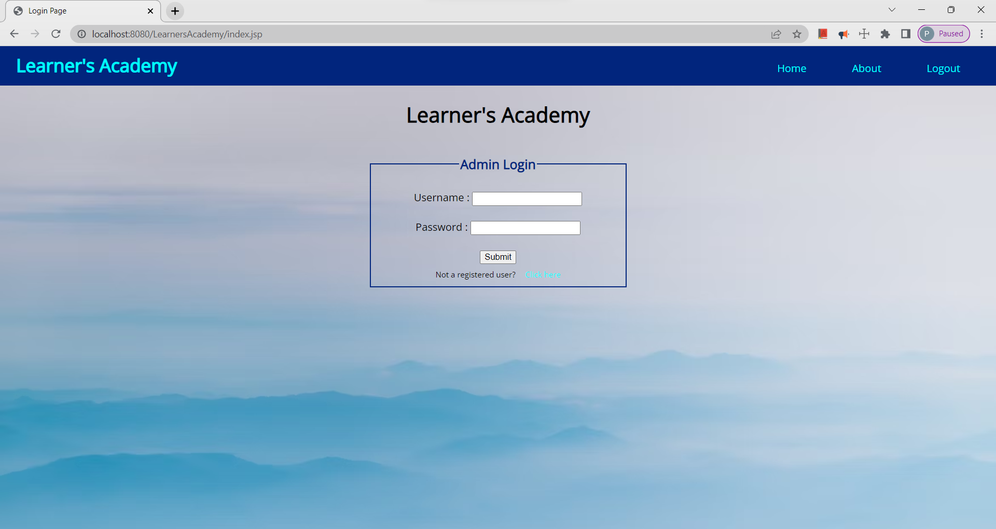

**Output2 : On hover**

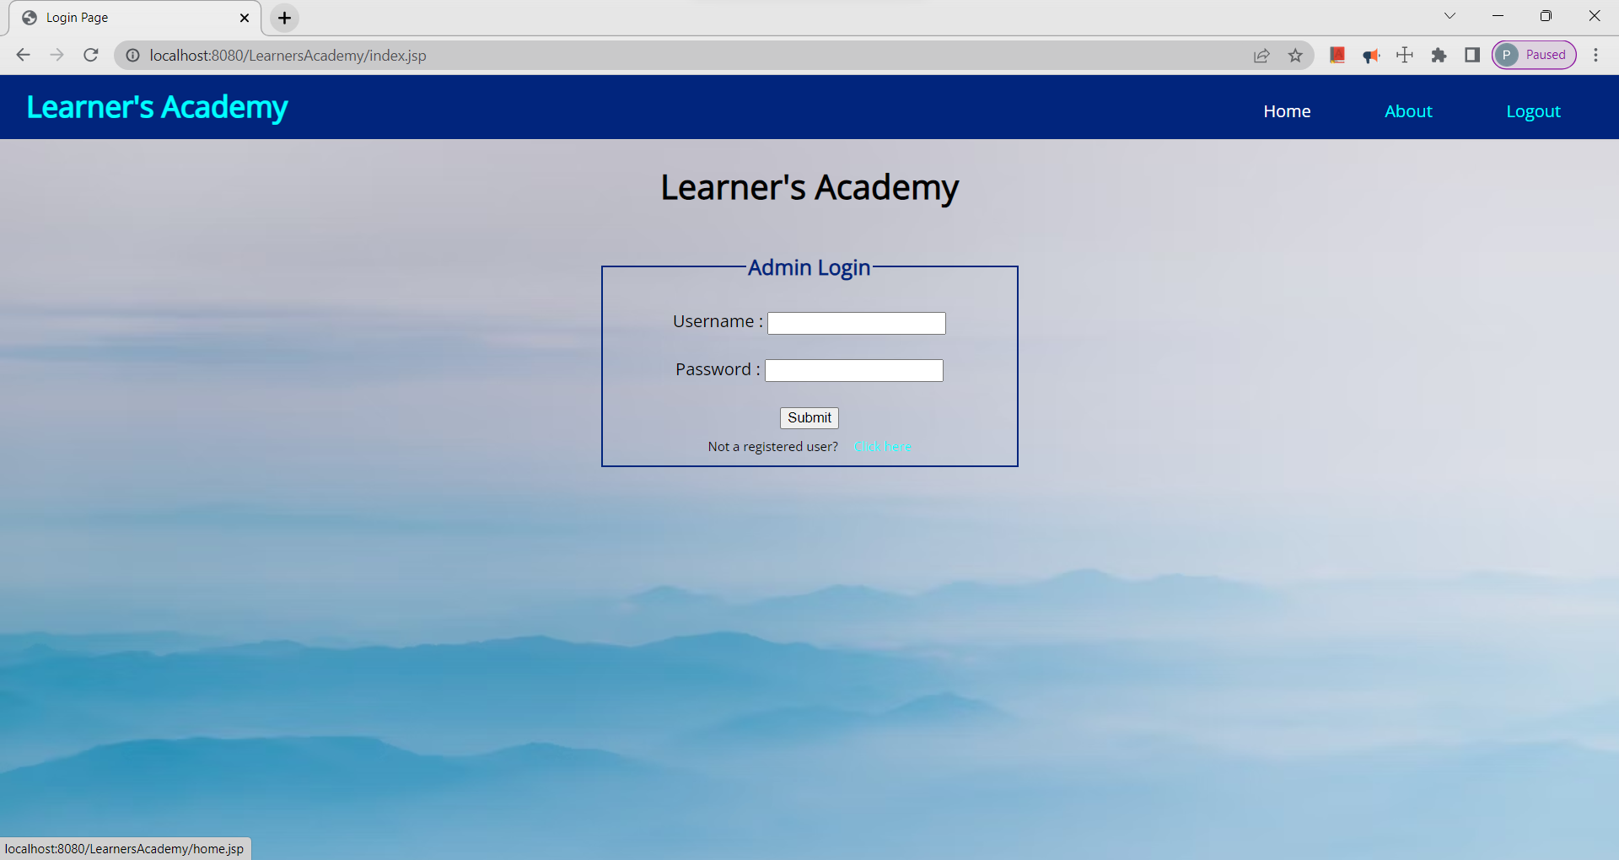

**Output3 : Registration form page**

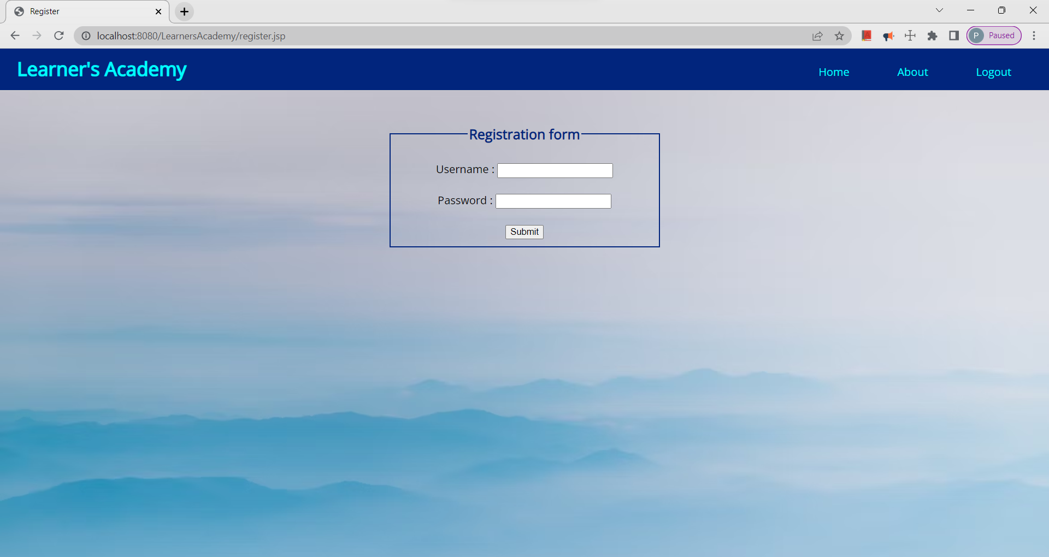

**Output4 : Registration Successful Page**

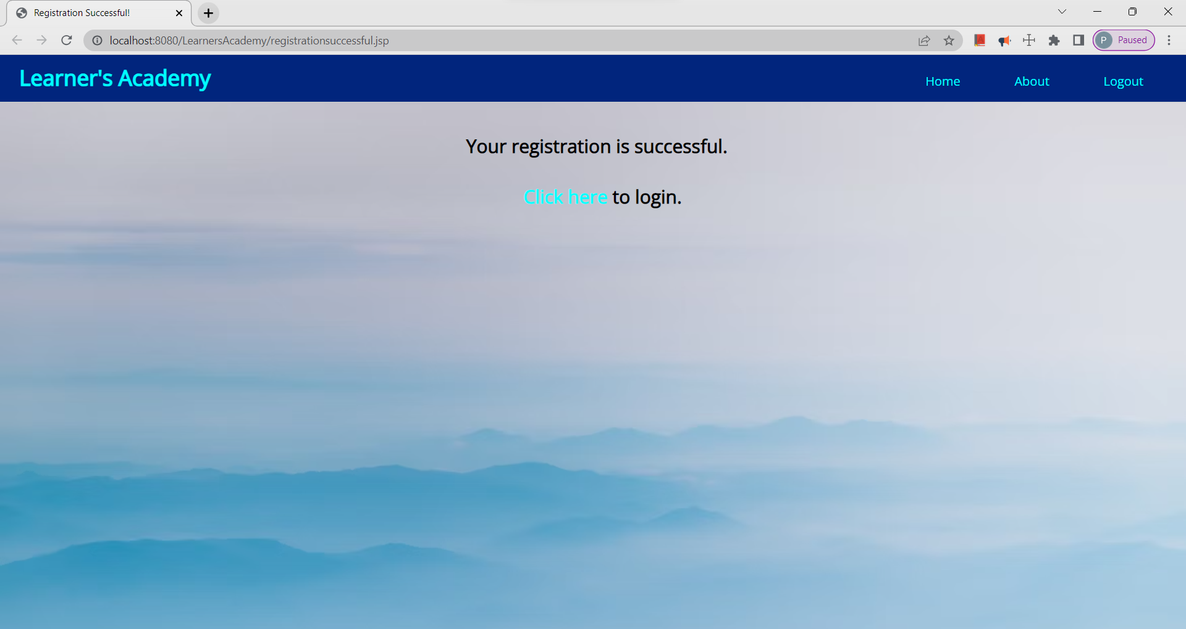

**Output5 : Home Page**

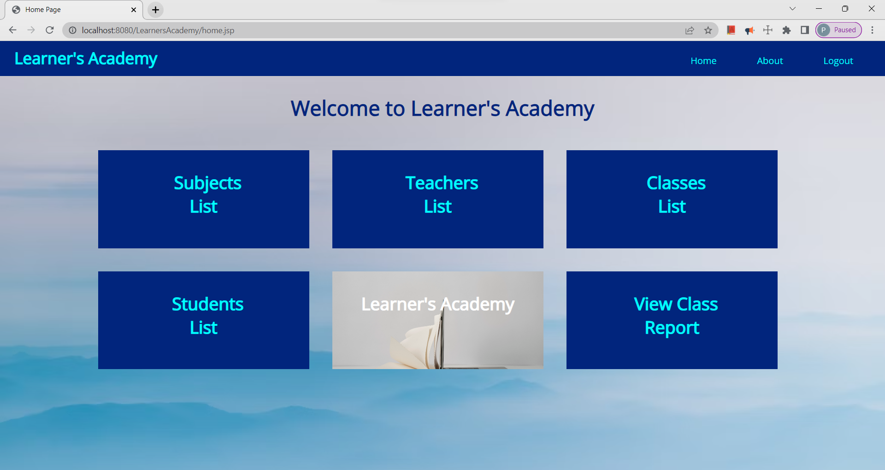

**Output6 : On hover**

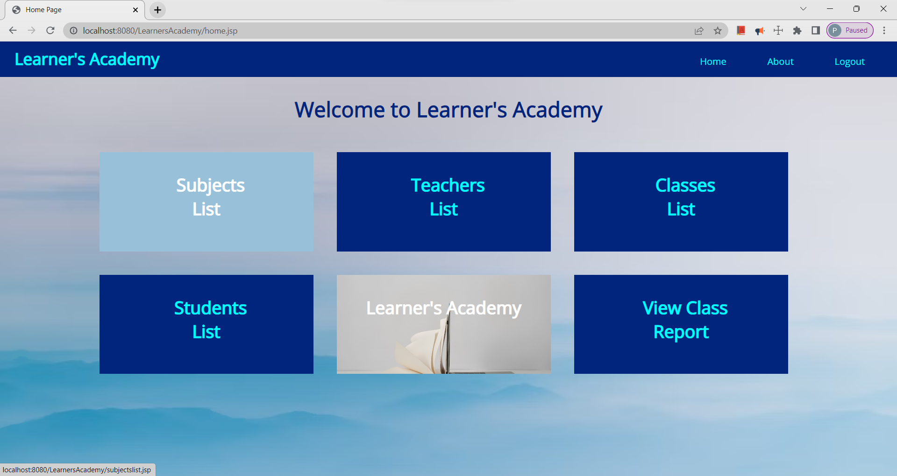

**Output7 : Subjects List Page**

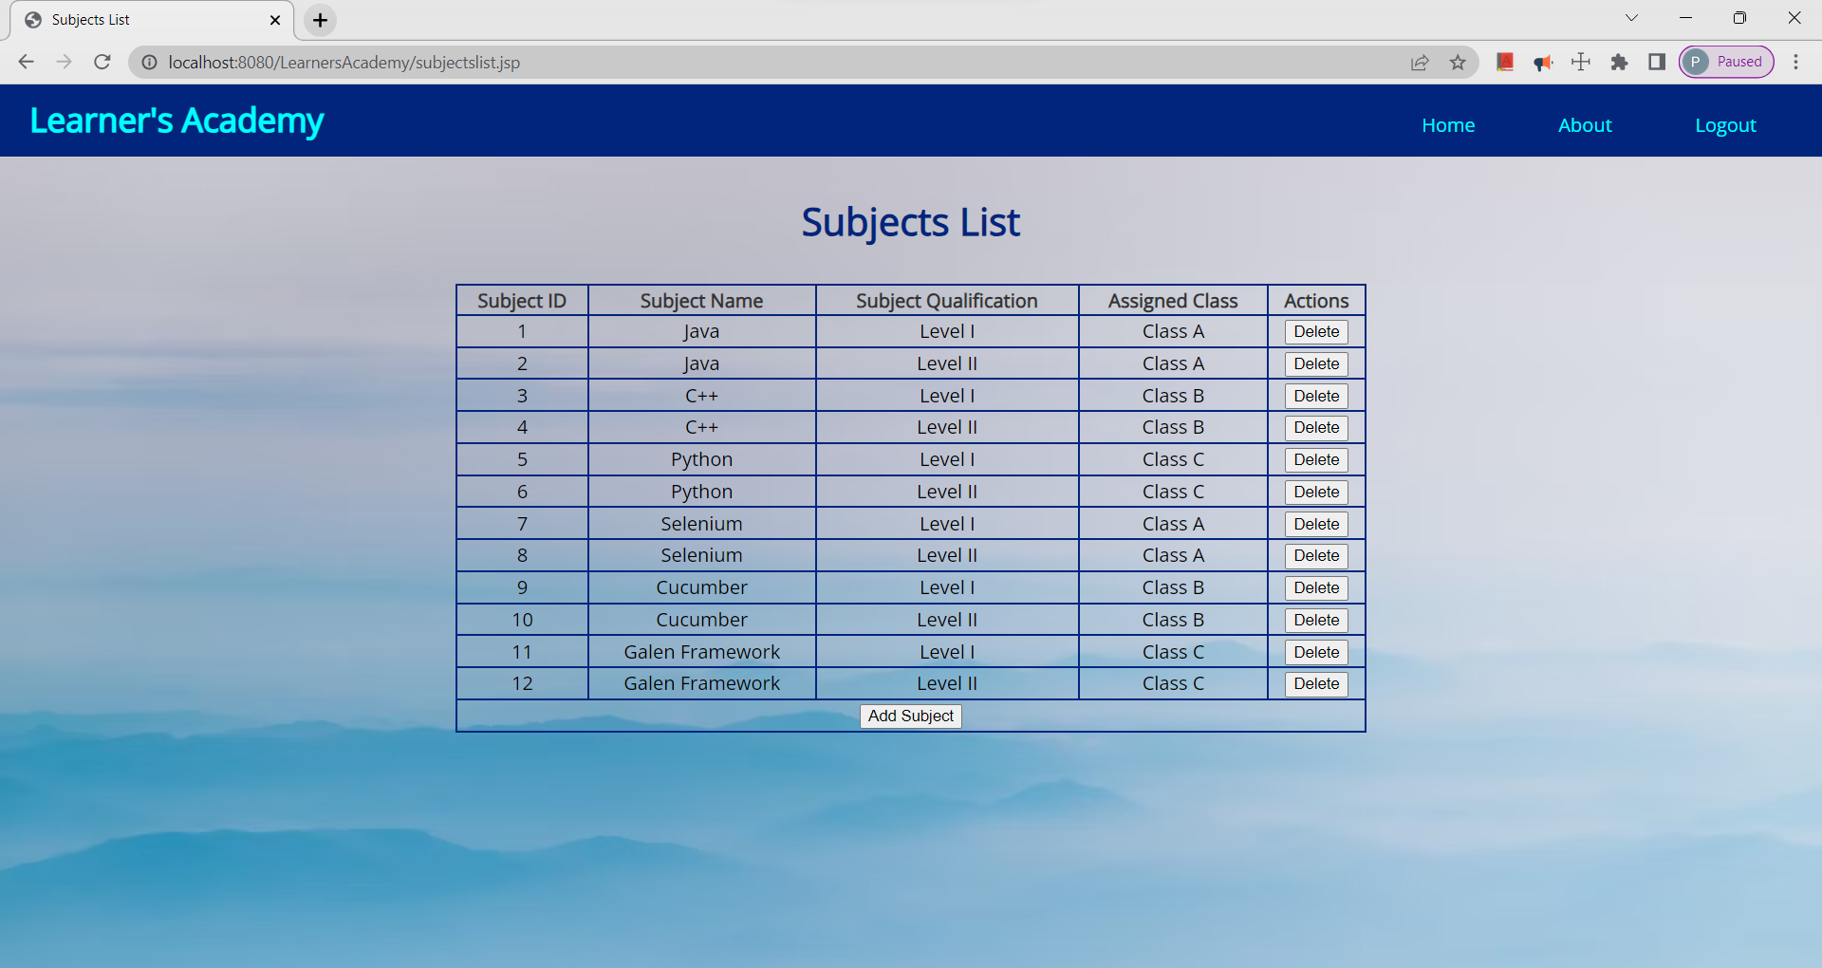

**Output8 : Add Subject Form**

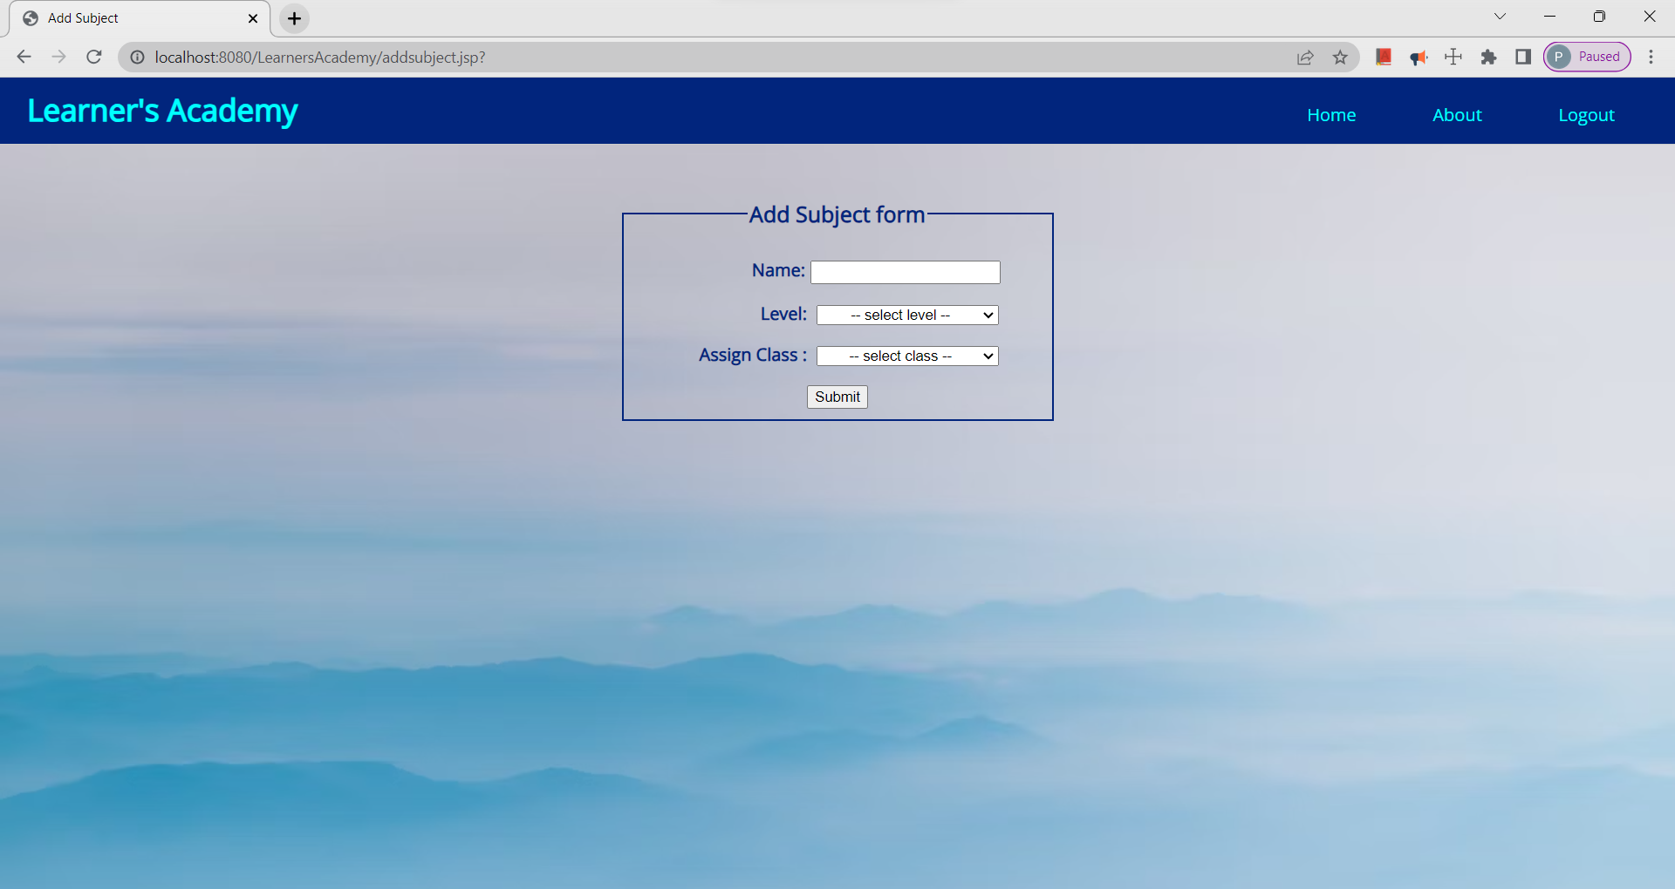

**Output9 : Teachers List Page**

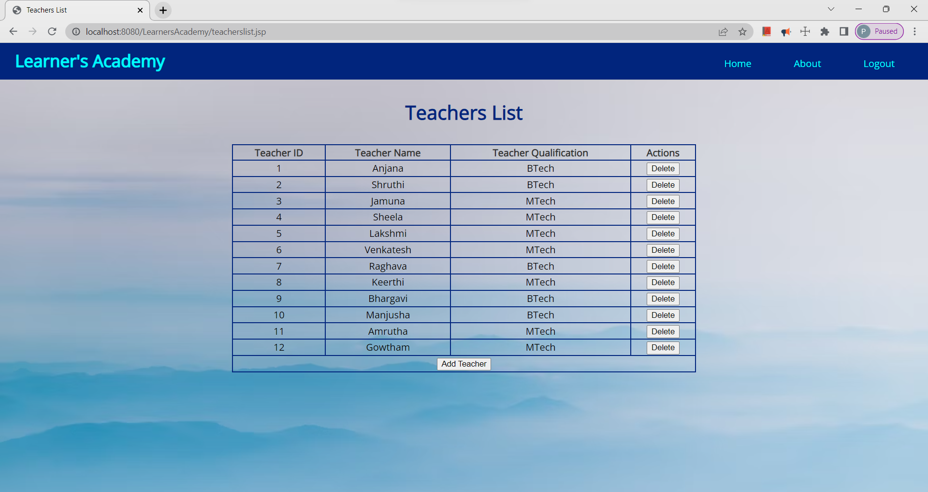

**Output10 : Add Teacher Form**

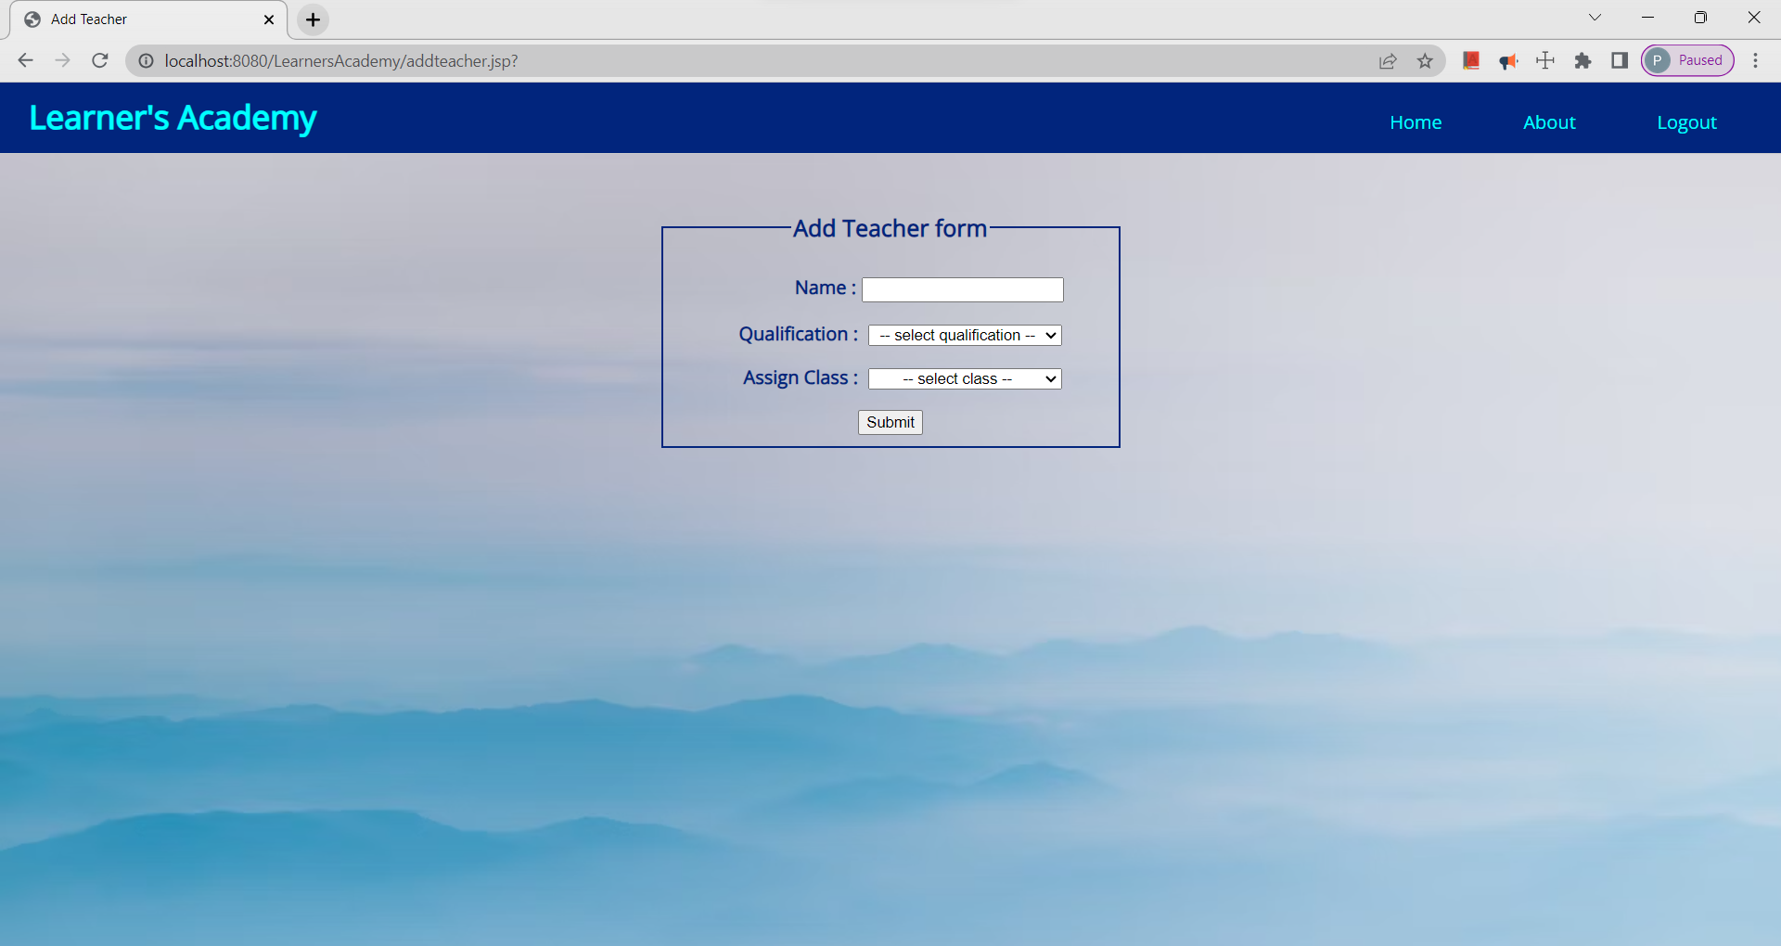

**Output11 : Classes List Page**

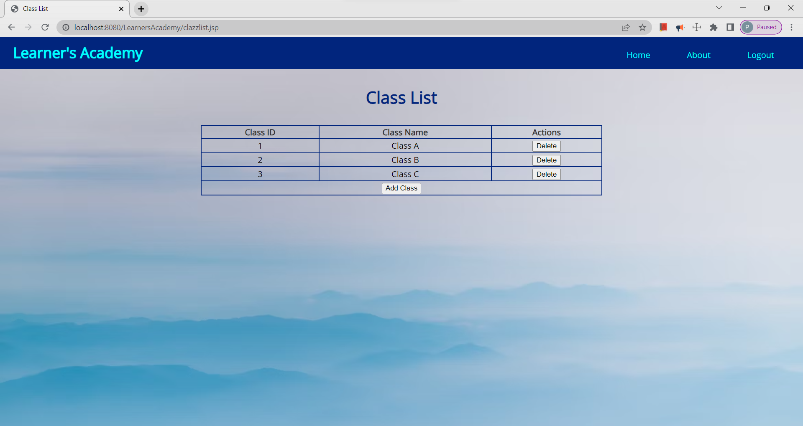

**Output12 : Add Class Form**

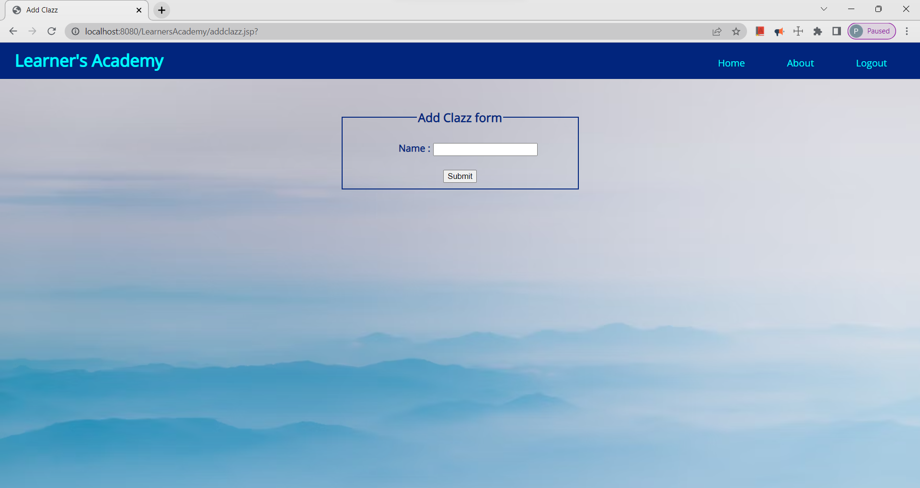

**Output13 : Students List Page**

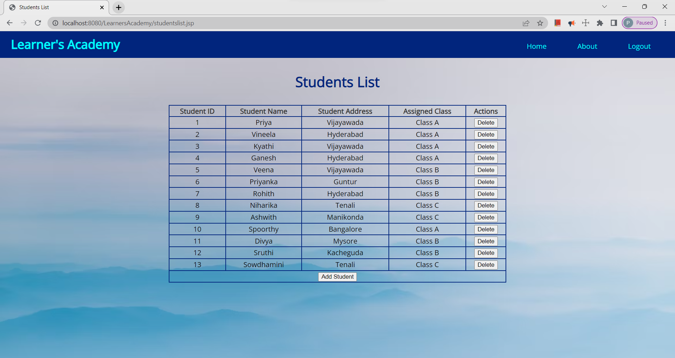

**Output14 : Add Student Form**

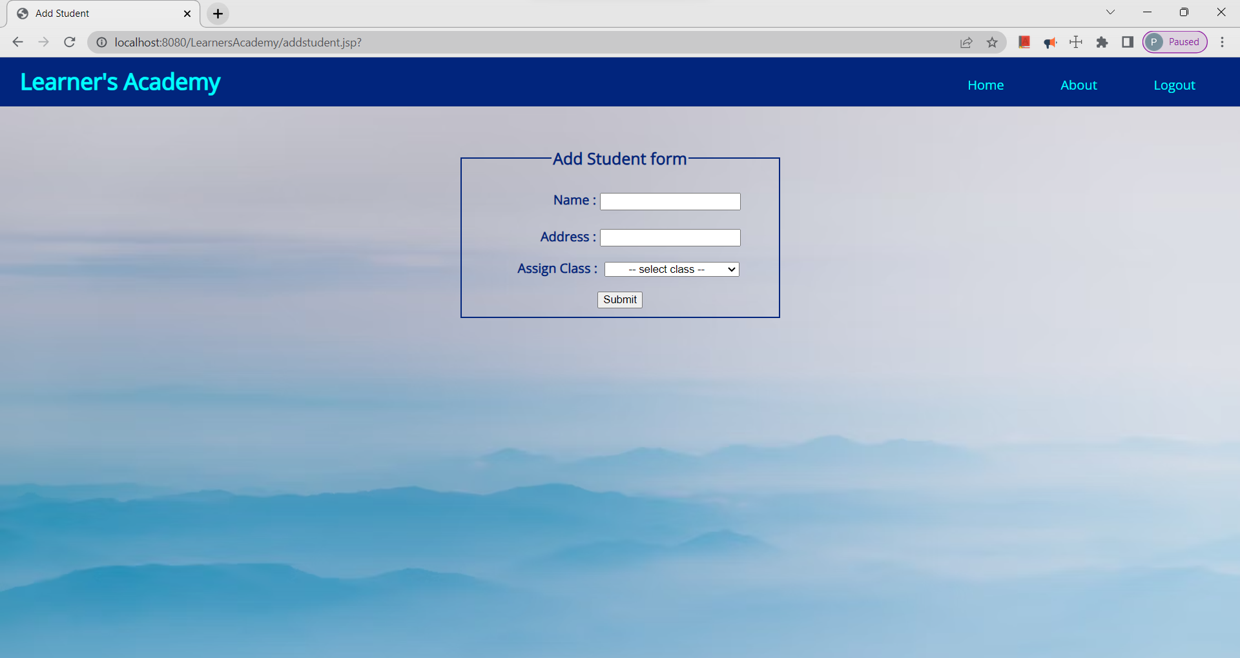

**Output15 : View Class Report**

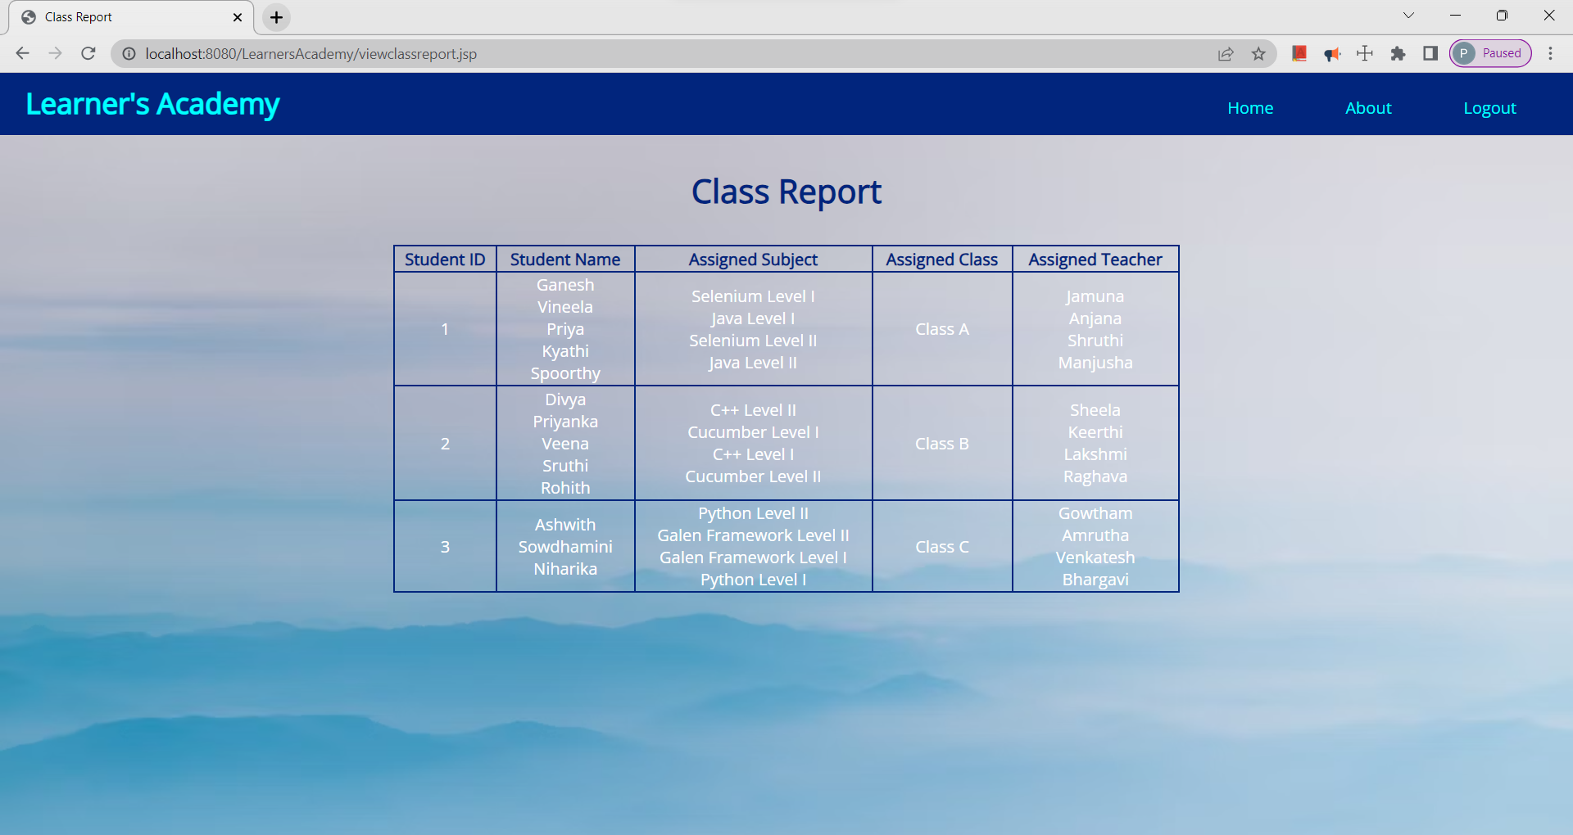

**Output16 : About**

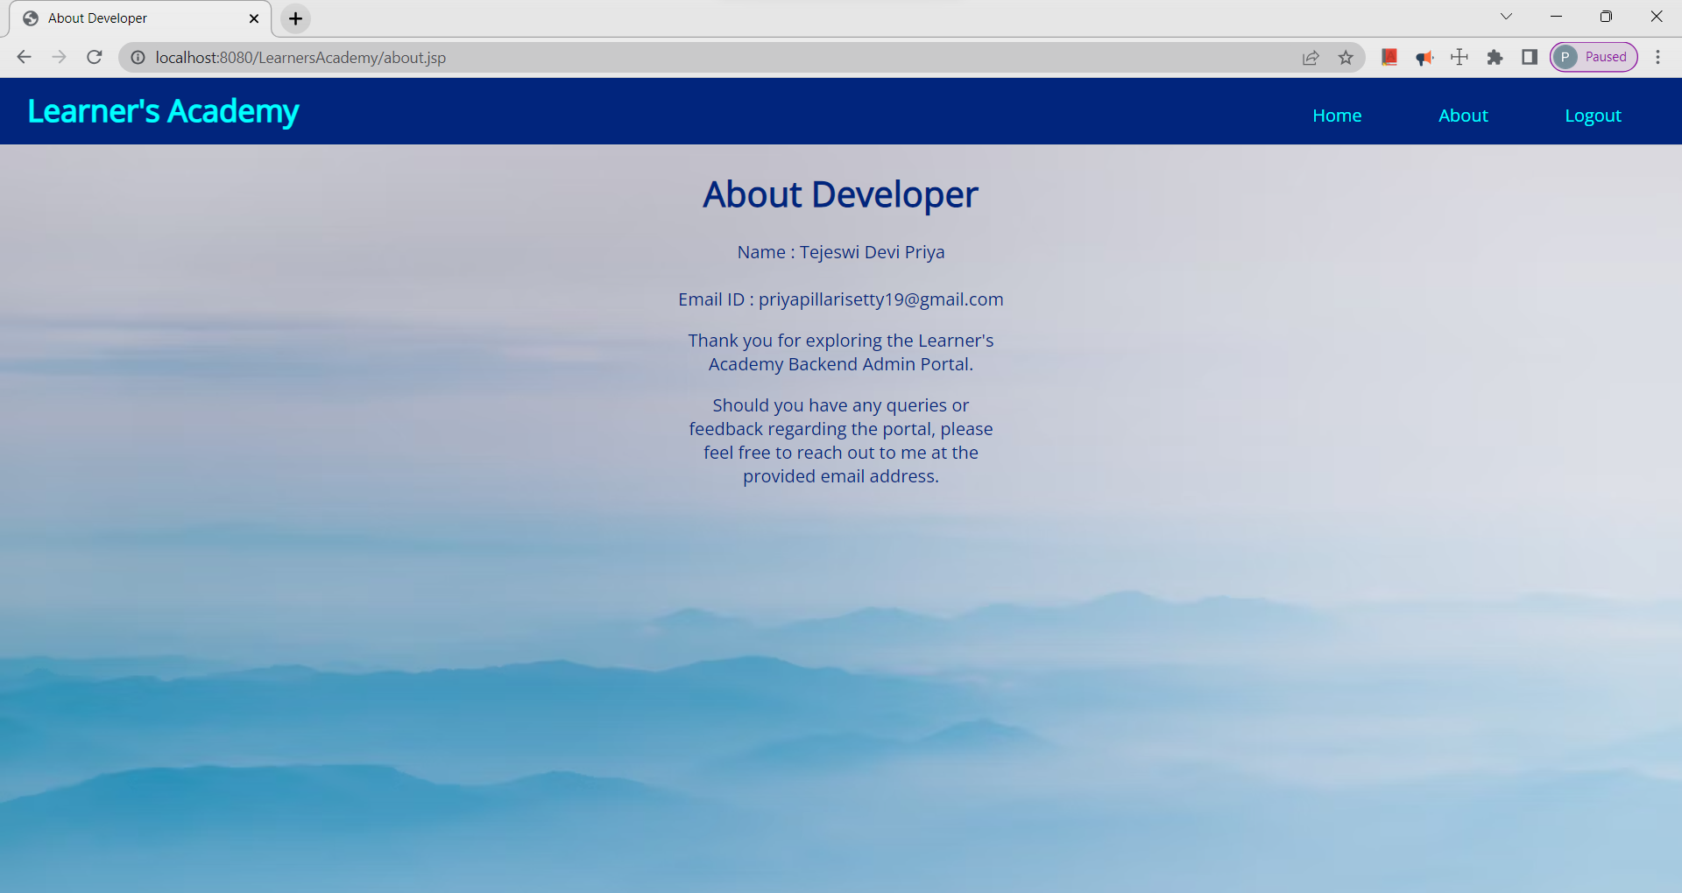

**Output17 : Logout Page**

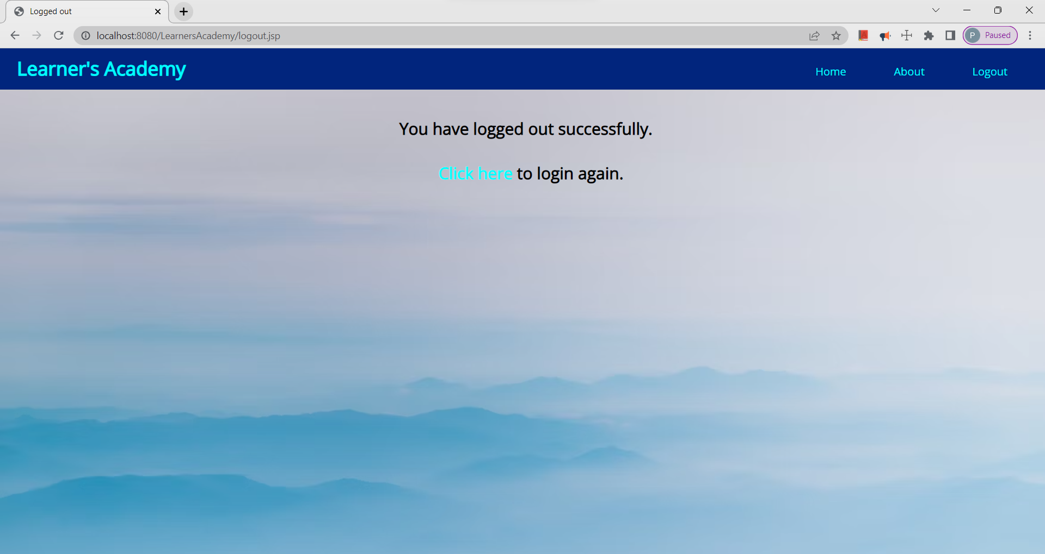

**Output18 : Invalid Credentials Page**

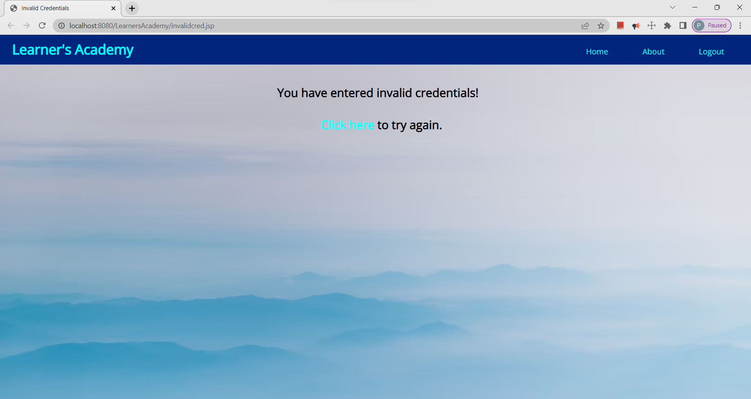

1. **Pushing the code to GitHub Repository:**

* Open Git Bash and navigate to the folder where you have created your files.

**cd Simplilearn\Phase2Projects\LearnersAcademy**

* Initialize the repository using the below command

**git init**

* Add all the files to your git repository using the below command

**git add .**

* Commit the changes using the below command

**git commit -m “Initial commit”**

* Add the URL for the remote repository where your local repository will be pushed

**git remote add origin https://github.com/Priya-2705/Learners-Academy.git**

* Push the files to the folder you initially created using below command

**git push -u origin master**

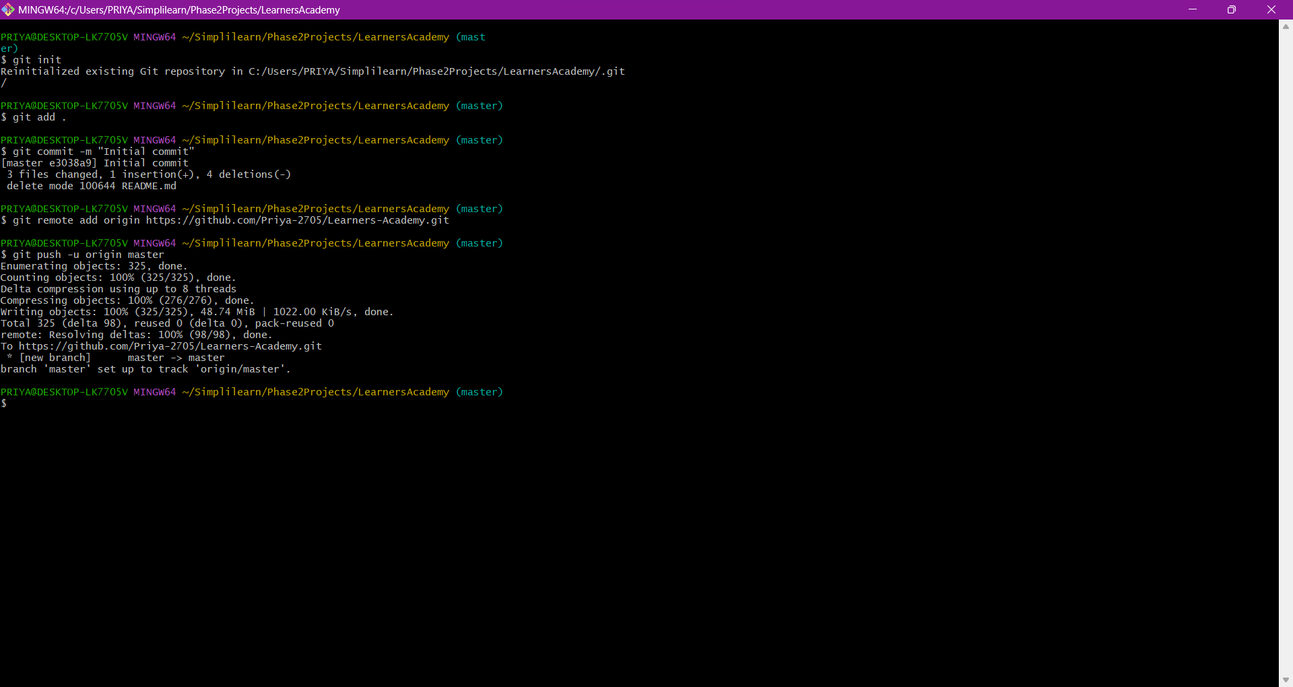

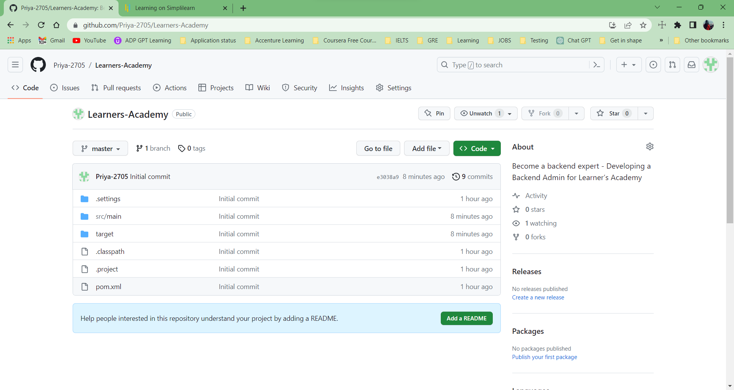

# Unique Selling Points of the Application:

* The application blocks anyone from accessing the website through home button from header without logging in.
* User is given the option to register themselves and create an account for themselves.
* If user enters invalid credentials, then user is redirected to an error page.

# Conclusion:

The application has been developed according to all the required features mentioned in the project description. Further enhancements to the application can be made by the following:

* Role-Based Access Control: Introduce role-based access control to differentiate between different types of administrators and assign different permissions based on their roles.
* Real-Time Notifications: Implement real-time notifications to alert administrators of any critical updates or changes made by other administrators.
* Search and Filter Functionality: Add search and filter options for different data sets, making it easier for administrators to find specific information quickly.